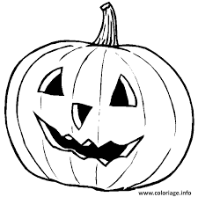
HALLOWEEN POETRY

A Halloween Pumpkin

I am a pumpkin, big and round
Once upon a time I grew in the ground, but
Now I have a mouth, two eyes and a nose
What are they for, do you suppose?
When I have a candle, inside, shining bright
I'll be a jack-o-lantern on Halloween Night,
Halloween Night!
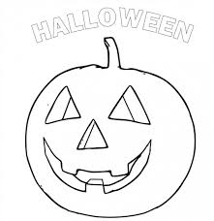

HALLOWEEN POETRY
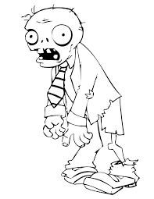

It Is Finally Halloween Time
It is finally Halloween time,
So together let us rhyme.
Skip the candies and the pumpkin,
Let us feast on blood tonight.
Jack O' Lantern is smiling bright,
Frankenstein is laughing at your plight.
Have a horrific Halloween.
