Geography Name:

BELGIUM
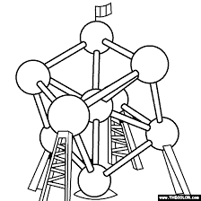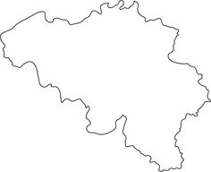
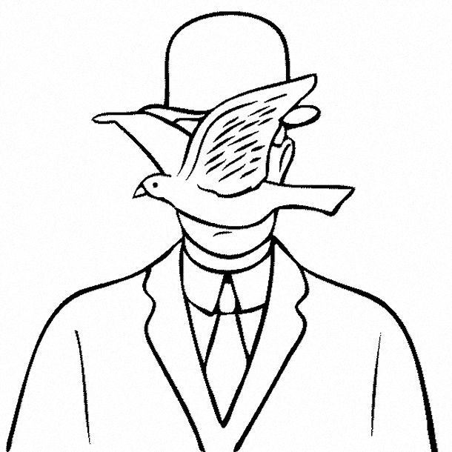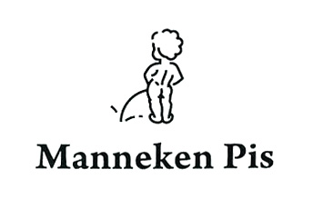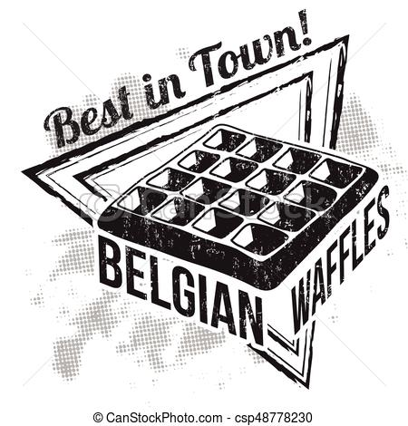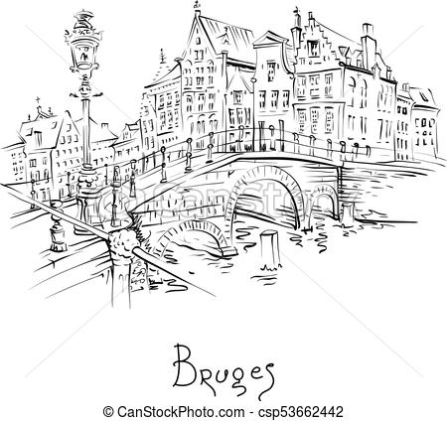
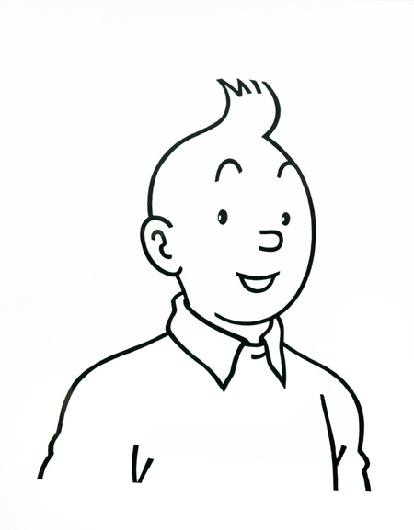
Hello, i'm Tintin, one of the most famous symbol of our wonderful country : Belgium.
Follow me to discover it ...

Here are a belgium map and neighbourings countries. Can you label the bordering countries (wich have a shared border).

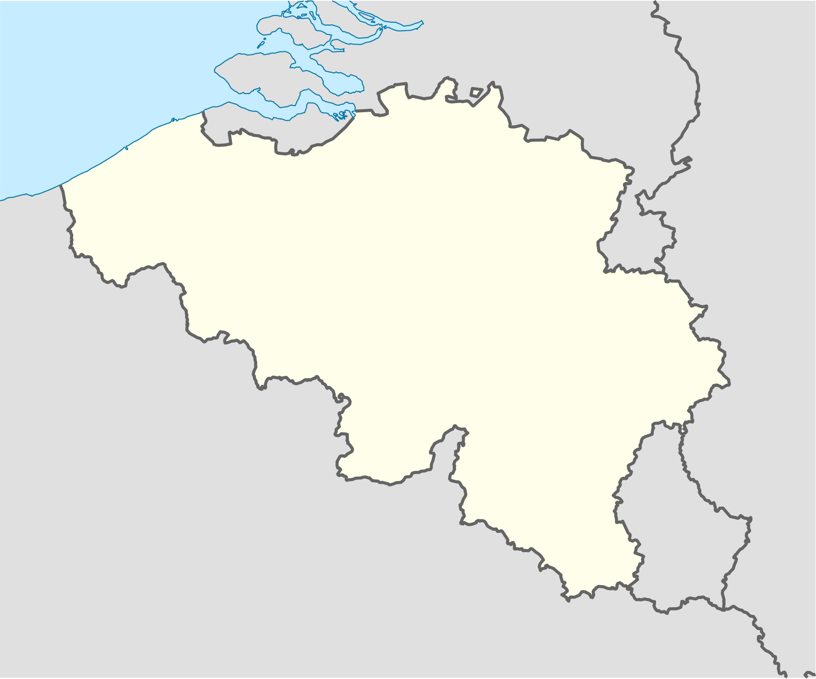

Complete the chart

COUNTRY | FLAGS | CAPITALS | POLITICAL REGIME*
BELGIUM  (Belgique) |  | ........................... | ..........................
FRANCE  (France) |  | ........................... | ..........................
GERMANY  (Allemagne) |  | .......................... | ..........................
NETHERLANDS  (Pays-Bas) |  | .......................... | ...........................
GRAND DUCHY OF LUXEMBOURG  (Grand Duché de Luxembourg) |  | .......................... | ..........................

All of these countries are europeans (they are on the european continent)
and they are members of the European Union.

* Monarchy (monarchie) = the country is governed by a king or a queen.
Republic (république) = the country is governed by an elected president.
SOME INFORMATION

- Belgium is situated in Europe, bordered by the Netherlands, by Germany, the Grand Duchy of Luxembourg and by France.
- Although its surface area of 30 528 km2 makes it a small country, its location has made it the economic and urban nerve centre of Europe.
- We are 11 267 910 inhabitants in Belgium (in 2016)
- National Day is celebrated on July 21. Its commemorates the day on which Leopold I took the constitutional oath as the first King of Belgium, on July 21st 1831.
- Maximum distance between two points = 280 kms.
- Geographical center of the country is Nil-Saint-Vincent
- The peak = the "Signal de Botrange" at 694 meters.

Vocabulary

Governed = gouverné Situated = situé
King = roi Elected = élu
Queen = reine Urban = urbain
Although = bien que Between = entre
West = ouest Inhabitants = habitants
North = nord Oath = serment
East = est Nerve center = centre névralgique
South = sud
Peak = sommet (point culminant)
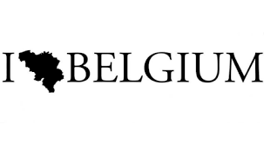

Belgium is a federal state, composed of regions, communities and provinces.

The regions

There are three Regions. The names of the three regional institutions are borrowed from the name of the territory they represent.

So we have (from north to south)
- the Flemish Region,
- the Brussels-Capital Region
- the Walloon Region.

The three regions have powers relating to the :
- economy, employment, agriculture, public works, energy, transport (except Belgian Railways), the environment, nature conservation, and scientific research for exemple
Each regions have his government and her ministers.
VOCABULARY
Borrowed = emprunté
They = ils, elles
Powers = pouvoirs
Relating to = concernant
Public works = travaux publics
Railways = chemin de fer
Research = recherche

With the Atlas, color the regions map.

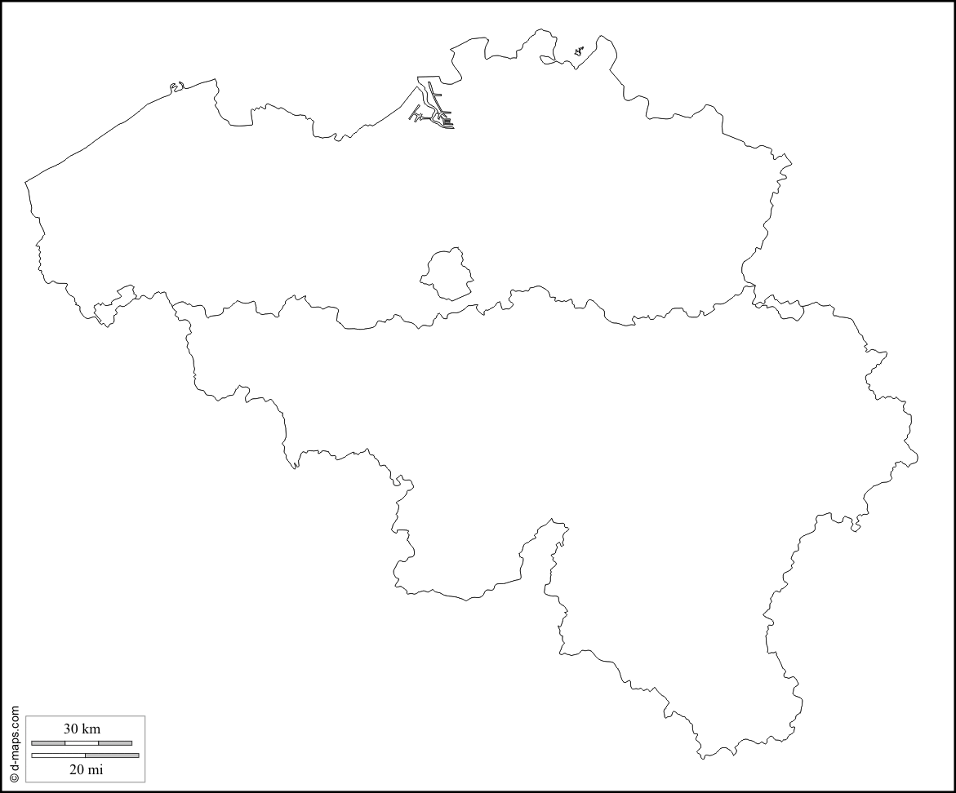
Complete the caption*
The Flemish region
* caption = légende
The Walloon region
The Brussels-capital region

The Communities

In addition to the three Regions, the Federal State has three Communities.
They are based on the "language".
So we talk about the Flemish, French and German-speaking Communities.
The Community has powers for culture (theatre, libraries, audiovisual media, etc.), education,
!! Pay attention, Brussels is not a community !!

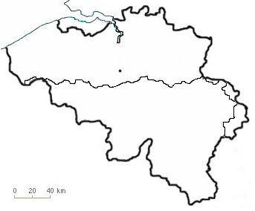

The provinces

After the regions and the communities, we also have some provinces in Belgium. Each one have a little "capital city" called CHEF-LIEU in french.

- Count how many provinces and chefs-lieux are on the map bellow

- There are ......... provinces and ........... chefs-lieux.
- Color each province in a different color
- With the atlas, label each province and his chef-lieu.

AN OTHER TOWN
COMMUNITY
REGION
CHEF-LIEU
PROVINCE | 1 | 2 | 3 | 4 | 5 | 6 | 7 | 8 | 9 | 10
OUR COUNTRY'S FLAGS.

The national flag is black, yellow and red.
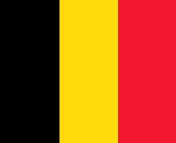

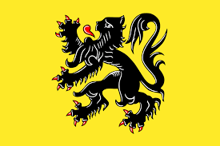

The flemish region and the flemish community flag : yellow with a black lion.

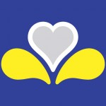

The Brussels capital region flag : Blue with a yellow iris flower and a heart

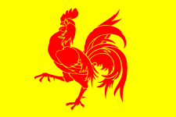 The Walloon region flag : yellow with a red rooster
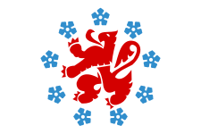

The german-speaking community : white with a red lion and nine blue gentian flowers.

THE NATIONAL ANTHEM = Hymne national

Our national anthem is the "Brabançonne".
National day is celebrated on July 21.

The song lyrics = les paroles

Ô Belgique, ô mère chérie,
À toi nos cœurs, à toi nos bras,
À toi notre sang, ô Patrie !
Nous le jurons tous, tu vivras !
Tu vivras toujours grande et belle
Et ton invincible unité
Aura pour devise immortelle :
Le Roi, la Loi, la Liberté !
Aura pour devise immortelle :
Le Roi, la Loi, la Liberté !
Le Roi, la Loi, la Liberté !
Le Roi, la Loi, la Liberté !

- There is any english version of the national anthem.

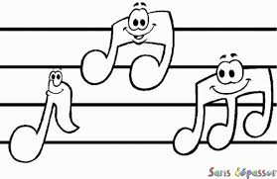 A LOT OF SYMBOLS

Place the correct name with the good picture.

 | 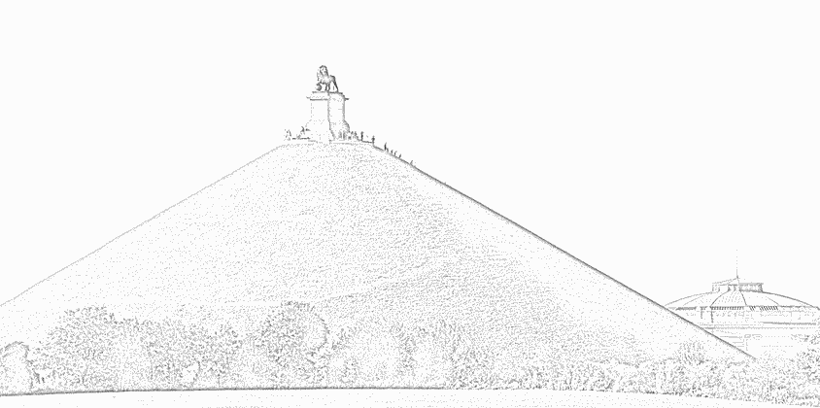 | 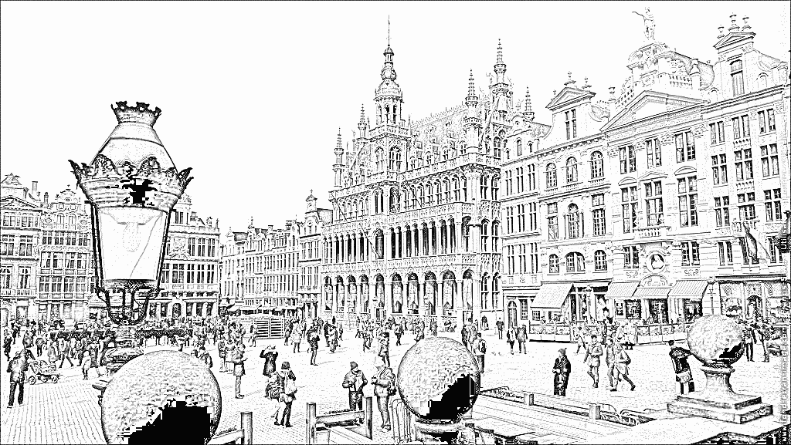
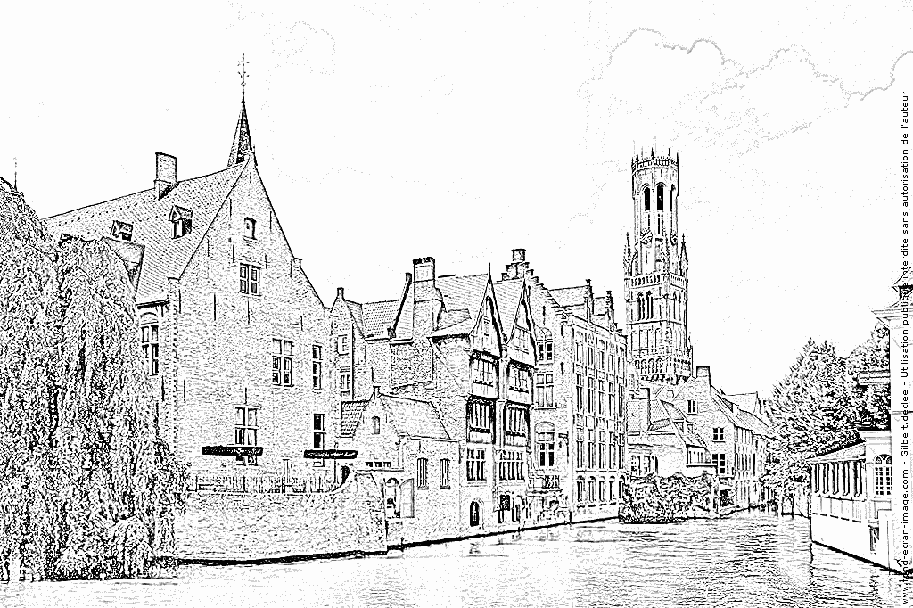 | 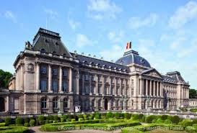 | 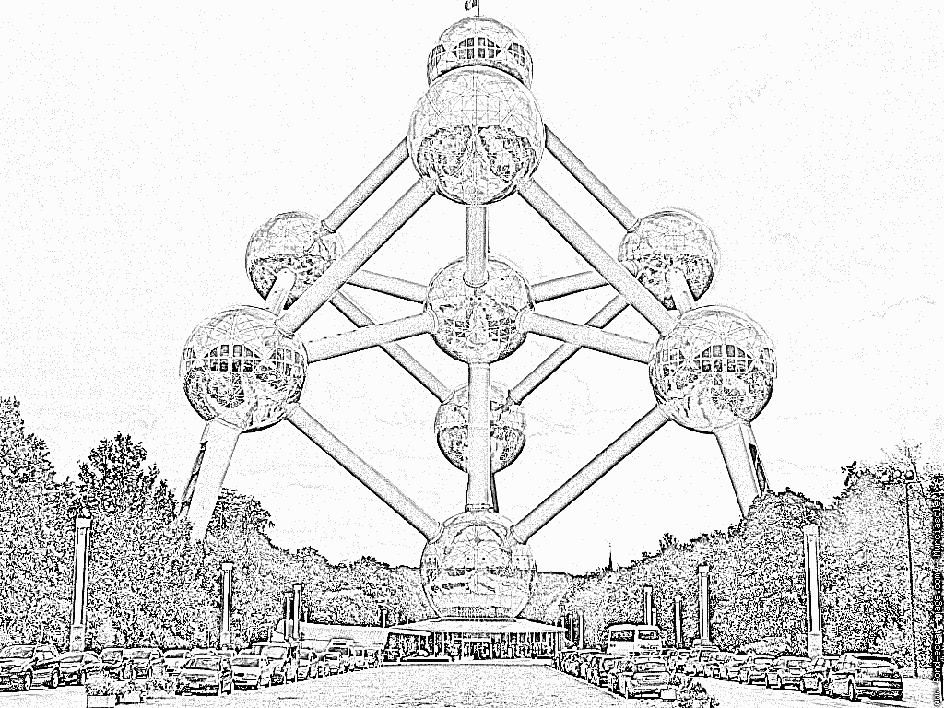
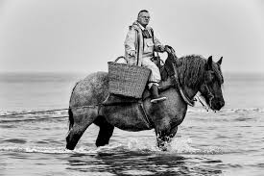 | 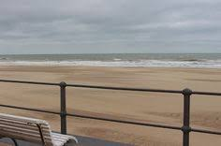 | 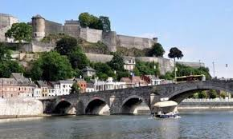

The lion of Waterloo - The atomium - The citadelle de Namur - The north sea - The royal palace of Brussels - The Manneken pis - The city and the belfry (beffroi) of Bruges - The Grand place in Brussels - The shrimp (crevette) fisherman on horse.

BELGIUM, A COUNTRY OF COMICS

Can you recognize the next comics heros ?

1) 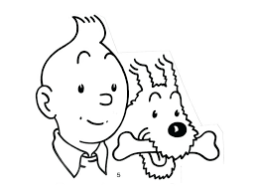 2) 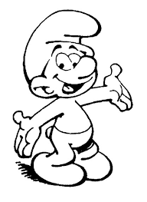 3) 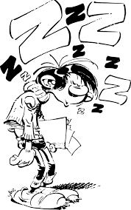 4) 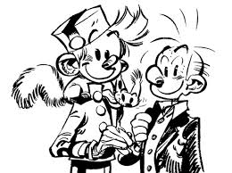

5) 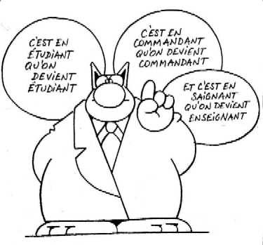 6) 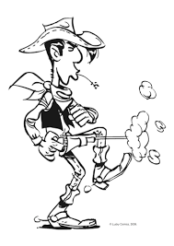 7) 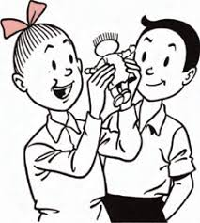 8)

9) 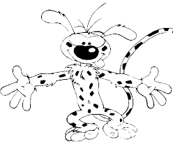 10) 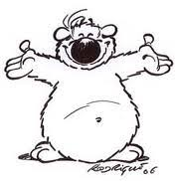
1 = ..................................................................

2 = ..................................................................

3 = ..................................................................

4 = ..................................................................

5 = ..................................................................

6 = ..................................................................

7 = ..................................................................

8 = ..................................................................

9 = ..................................................................

10 = ..................................................................

VOCABULARY
(To) place = placer A country = un pays
Correct = correcte, bonne Comic = bande dessinée
With = avec Can you = peux-tu ?
Good = bonne recognize = reconnaître
Picture = image, photo next = suivant

WHAT ARE OUR CULINARY SPECIALITIES ?

Connect the specialities with the right number
1 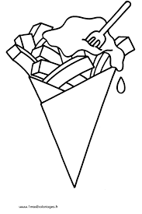 2) 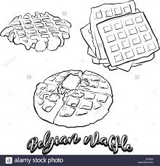 3) 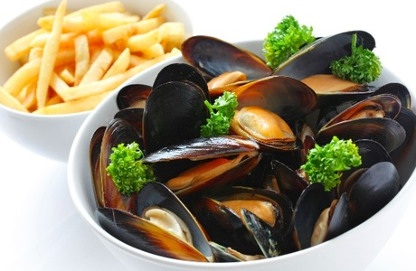

4) 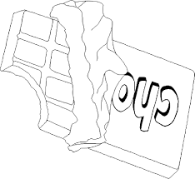 5) 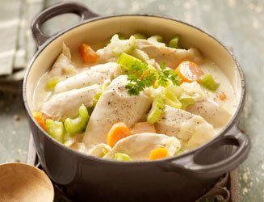 1 Chocolate

2 Waterzooï

3 French fries / chips

4 Waffels

5 Mussels and french fries
SOME QUESTIONS / INFORMATIONS

- Our country is a monarchy, do you know the name of our monarchs ?
The King .................................. and the Queen .....................................
- The capital of Belgium is ......................................................
- Our national currency is the .......................................
- When we celebrate the national day ? .........................................
- In Belgium, we are talking three different languages. Can you mention them? .........................................
.........................................
.........................................
- What is the name of our Prime Minister ? .............................................
- Do you know a famous singer ? .......................................................
- Do you know a famous sportman / sportwoman ? .....................................................................
- In wich province are you living? ....................................................

Vocabulary
Monarchs = souverains National day = fête nationale
King = roi we are talking = nous parlons
Queen = reine mention them = les citer
Our = notre prime minister = premier ministre
National currency = monnaie nationale famous = célèbre
When = quand singer = chanteur

