Name :

Word problems: the receipt

The important things to resolve correctly the next problems.

1) Read and understand the statement.
2) Underline the important informations with your highlighter pen.
3) Classify the data (What i know, what i'm looking for...)
4) Pay attention when you calculate : peer the sign of the operation !
5) if i ask you an answer with a sentence, phrase dit in a clear way.

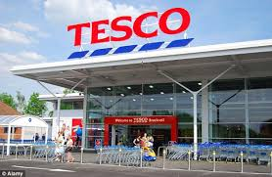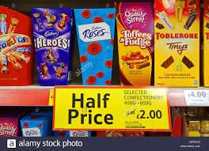

Word problems: the receipt

Take a close look to the receipt.

TESCO

£

FRESH MILK 1.39
HOVIS BREAD 1.25
FROZEN PIZZA 2.53
FROZEN PIZZA 2.53
T MILD CHEESE 3.24
GARL FLATBREAD 1.77
STEAK MINCE 2.89
PEAS & CORN 1.49
FAIRY LIQUID 1.46
HANDWASH 1.99
HANDWASH 1.99
KITCHEN FOIL 1.88
FLOWERS 2@ 3.00 6.00
MCCOYS 0.75
RED PEPPER 0.86
BANANAS LOOSE
0.630KG @ £0.68/KG 0.43
LEMON LOOSE
0.630KG @ £1.38/KG 0.87
ONION LOOSE
0.150KG @ £0.87/KG 0.13
GREEN PEPPER 0.72

TOTAL PIECES ..........

TOTAL
VISA DEBIT
CHANGE

===========================
THANK YOU FOR SHOPPING AT TESCO (BROCKWORTH)
===========================

11/01/13 10:23 3480 012 1232 5413

Word problems: the receipt

1) What's the name of the market where i went for my shopping ?
..........................................................
2) Circle, in red, the city's name on the receipt.
3) When did i make my shopping ?
..........................................................
4) Which articles/products i bought twice ?
...............................................................................................................................................................................................................
5) Underline, in fluorecent yellow, the purchased fruits.
6) Calculate the total of the receipt and write it on (you can use your calculator).
7) Complete on the receipt, the total of pieces.
8) Which product costs a half than another ?
..........................................................
9) Which product costs 1,49 £ ?
..........................................................
10) On the receipt, underline in blue, the personal and home care products.
11) What means of payment did i use ?
..........................................................

12) How many cost the kilo of onion ?
..........................................................
13) What's the price of a bunch of flower ?
..........................................................
14) Order the price from the greatest to the smallest.
........................................................................................................................................................................................................................................................................................................................
15) Which product has the less price ?
..........................................................
16) Which product has the high price ?
..........................................................
17) I decide to pay cash, how much will I get on a 50-pound note ?
Calculate

18) Can you make the total of the non-food products? (don't use the calculator) ?

