  0 + 1 | 20 – 17 | 2 + 3 | 19 – 2
17 – 15 | 3 + 1 | 2 + 2 + 2 | 18 – 10
  6 + 3 | 16 – 5 | 5 + 7 | 9 + 6
2 + 8 | 9 + 5 | 7 + 6 | 19 – 3
15 – 8 | 10 + 7 | 20 – 1 | 6 + 5
13 – 5 | 9 + 9 | 10 + 9 + 1 | 4 + 8
17 – 8 | 5 + 5 | 7 + 7 | 3 + 12
12 – 6 | 8 – 3 | 6 + 13 | 8 + 8
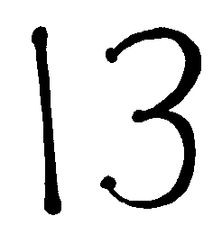



   |  | 16 | 17

