Synthèse : les Jeux Olympiques
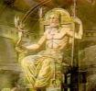  ................................................  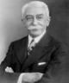  ...............................................  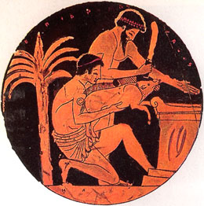  .......................................................  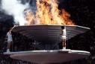  .........................................................  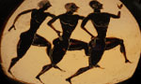  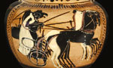  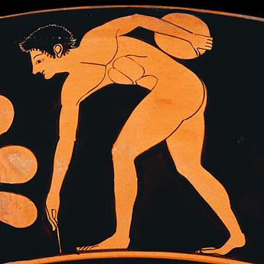  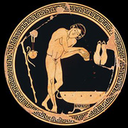  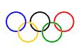  .........................................................  ..........................................................  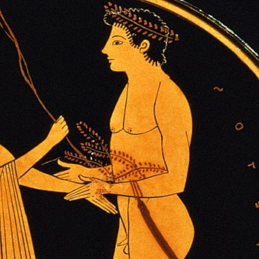  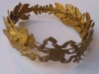   | Thème 1 : .......................................................  ...................................................................................................  ...................................................................................................  ...................................................................................................  ...................................................................................................  ...................................................................................................  ..................................................................................................  ..................................................................................................  Thème 2 : ........................................................  ...................................................................................................  ...................................................................................................  ...................................................................................................  ...................................................................................................  ...................................................................................................  ...................................................................................................  ....................................................................................................  ....................................................................................................  Thème 3 : .............................................................  ..................................................................................................  ..................................................................................................  ..................................................................................................  ..................................................................................................  ..................................................................................................  ..................................................................................................  ..................................................................................................  ..................................................................................................  Thème 4 : .........................................................  ..................................................................................................  ..................................................................................................  ..................................................................................................  ..................................................................................................  ...................................................................................................  ..................................................................................................  ..................................................................................................  ...................................................................................................  ..................................................................................................  Thème 5 : ..............................................................  ...................................................................................................  ..................................................................................................  ..................................................................................................  ..................................................................................................  ..................................................................................................  .................................................................................................  .................................................................................................  .................................................................................................  .................................................................................................

