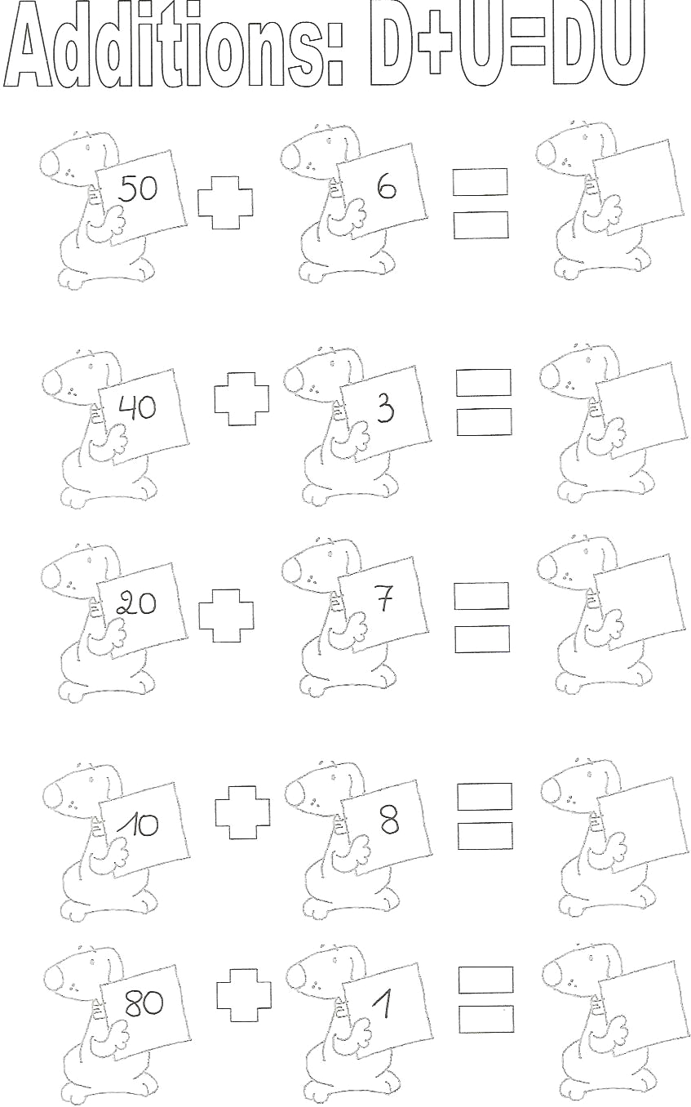

50 + 3 = | 70 + 2 = | 4 + 50 = | ___ + 10 = 14
30 + 2 = | 10 + 9 = | 3 + 20 = | 20 + ___ = 28
20 + 6 = | 30 + 8 = | 7 + 10 = | 60 + ___ = 69
30 + 9 = | 40 + 2 = | 3 + 30 = | ___ + 7 = 37
40 + 8 = | 70 + 6 = | 8 + 20 = | 56 = 50 + ___
10 + 8 = | 20 + 4 = | 7 + 60 = | 25 = ___ + 20
40 + 5 = | 30 + 0 = | 0 + 40 = | 38 = 30 + ___
30 + 1 = | 40 + 4 = | 9 + 50 = | 27 = ___ + 20
80 + 0 = | 20 + 9 = | 0 + 10 = | 98 = ___ + 90
60 + 5 = | 90 + 5 = | 8 + 30 = | 10 + ___ = 19

