Des calculs avec saint Nicolas.
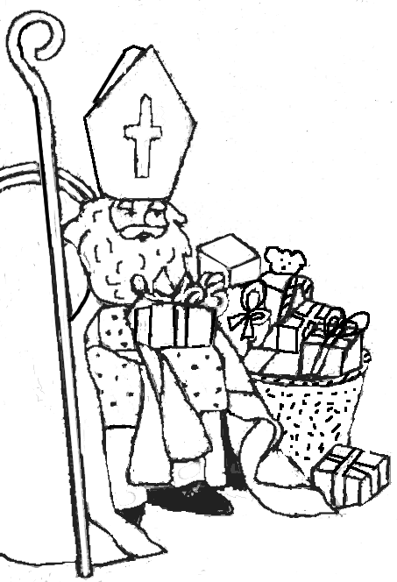
Sois très attentif (ve) !
Calcule vite et bien…
60 + 10 = ___  50 – 30 =  99 = 90 + ___  96 – 6 = ___  75 = 30 + ___  35 + 2 = ___  86 – 2 = ___  3 + 45 = ___  96 – 3 = ___  32 + 7 = ___  80 + 20 = ___  75 + 3 = ___ | 9 + 20 = ___  8 + 30 = ___  52 - ___ = 50  100 – 50 = ___  9 + 50 = ___  60 + ___ = 80  95 – 80 = ___  46 + ___ = 76  74 – 70 = ___  4 + 61 = ___  50 + 40 = ___  8 + 11 = ___ | 85 = 5 + ___  50 + ___ = 58  76 = ___ + 71  55 – 50 = ___  ___ + 20 = 69  77 – 7 = ___  70 – 60 = ___  34 + 4 = ___  100 – 50 = ___  96 = ___ + 6  45 = 40 + ___  50 – 20 = ___
Bon travail !

Vive les calculs !
A toi de trouver
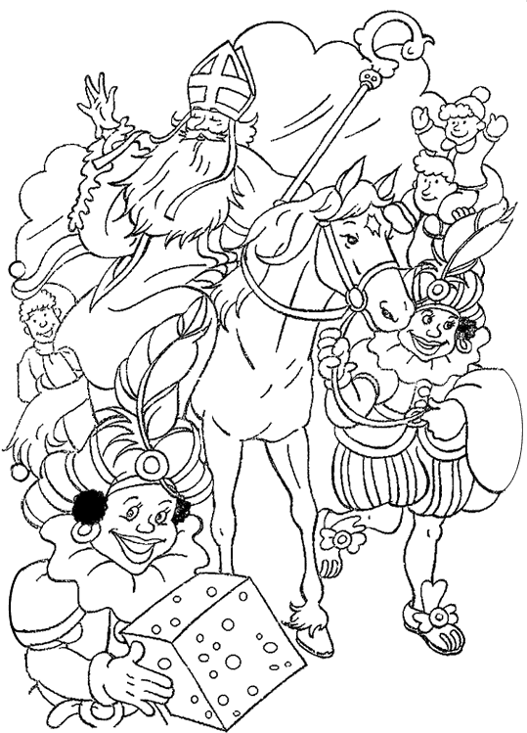
toutes les réponses !

60 + 20 = ___
30 + 50 = ___

70 = 10 + ___
90 = 40 + ___

20 + ___ = 80 26 + 3 = ___
40 + ___ = 50 86 - ___ = 80
100 = 70 + ___ 24 + 4 = ___
41 + 7 = ___
___ + 20 = 60 65 + 3 = ___
___ + 40 = 90 7 + 52 = ___
4 + 83 = ___
10 + ___ = 30 90 + ___ = 98
80 + ___ = 90 7 + ___ = 37
76 + ___ = 79
76 = 6 + ___
57 – 50 = ___
Entraine-toi
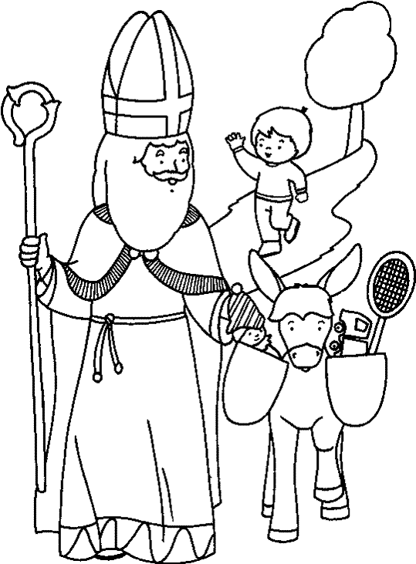

Des additions.

26 + 3 = ___  34 + 4 = ___  23 + 6 = ___  52 + 7 = ___  5 + 72 = ___  91 + 4 = ___  64 + 4 = ___ | 17 + 20 = ___  20 + 38 = ___  33 + 60 = ___  10 + 39 = ___  57 + 20 = ___  66 + 10 = ___  30 + 34 = ___
Des soustractions.

95 – 2 = ___  38 – 4 = ___  47 – 3 = ___  56 – 5 = ___  49 – 9 = ___ | 79 – 80 = ___  97 – 20 = ___  68 – 60 = ___  49 – 10 = ___  72 – 10 = ___ | ___ - 3 = 52  ___ - 4 = 31  86 - ___ = 80

Un peu de tout.

74 + ___ = 76  82 + 6 = ___  39 – 4 = ___ | 45 + 30 = ___  97 – 2 = ___  97 – 60 = ___ | ___ + 2 = 42  ___ - 4 = 25  83 - 10 = ___

