P’rénom : ___________
Passage par la dizaine : des additions.

Je me rappelle.
10+ 1 = . 10+ 4 = . 10+ 7 = .
10+ 2 = . 10+ 5 = . 10+ 8 = .
10+ 3 = . 10+ 6 = . 10+ 9 = .

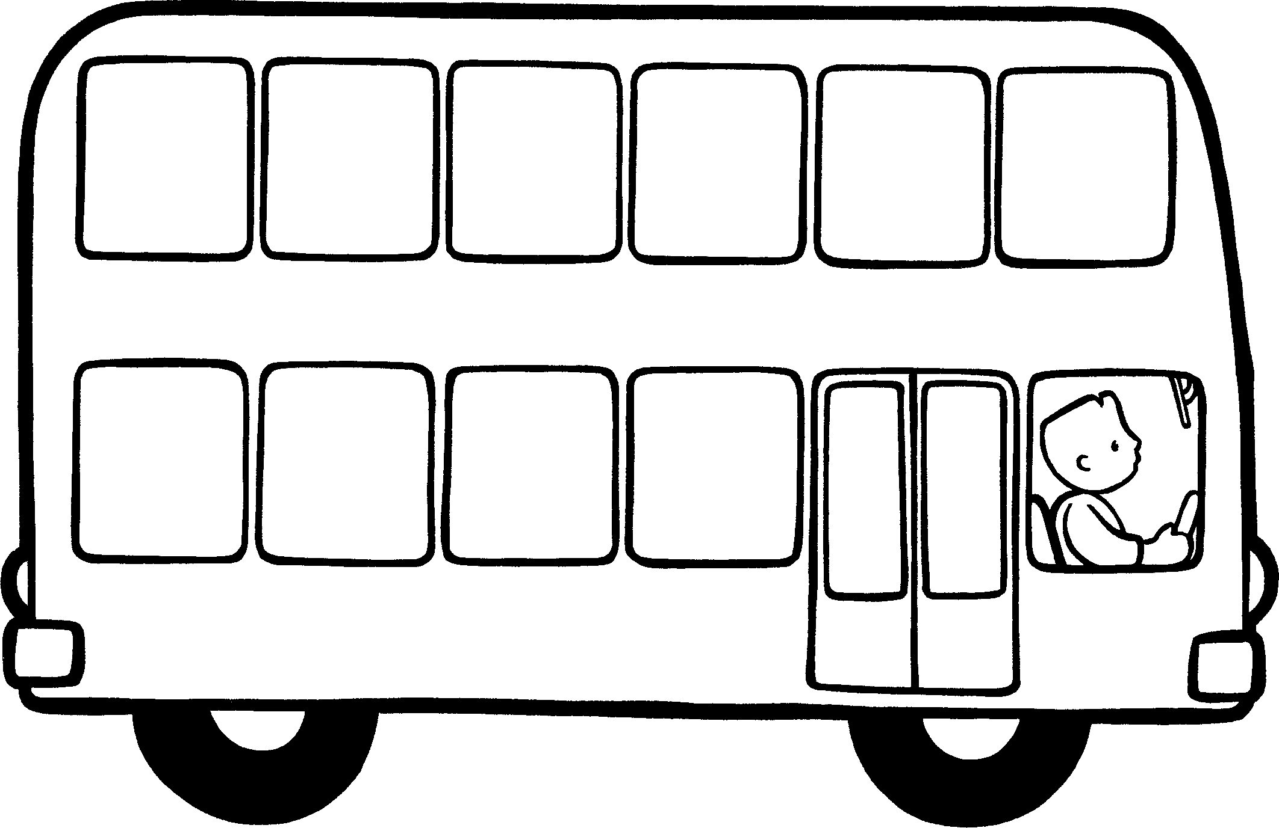  7 + 5 = (7 + .)+ . = . | 9 + 4 = (9 + .)+ . = .
8 + 6 = (8 + .)+ . = . | 6 + 9 = (6 + .)+ . = .
9 + 9 = (9 + .)+ . = . | 8 + 5 = (8 + .)+ . = .
6 + 7 = (6 + .)+ . = . | 8 + 8 = (8 + .)+ . = .
4 + 8 = (4 + .)+ . = . | 9 + 7 = (9 + .)+ . = .
7 + 6 = (7 + .)+ . = . | 5 + 8 = (5 + .)+ . = .
6 + 7 = (6 + .)+ . = . | 9 + 6 = (9 + .)+ . = .

