Mesures de Longueur
A toi de Jouer !!!

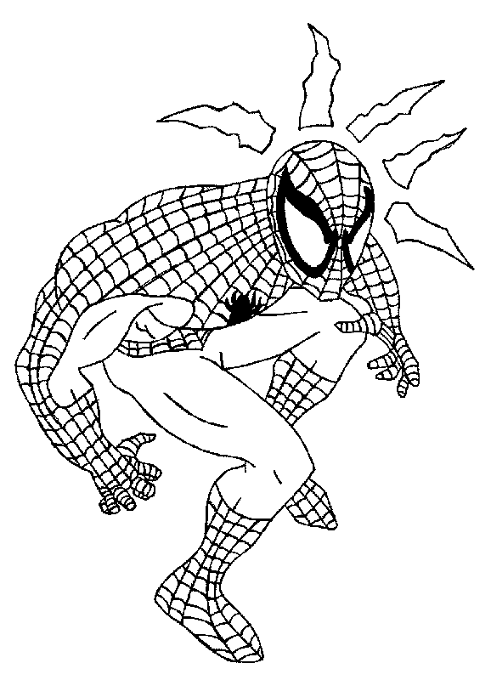

Donc je la lance à …
Je lance ma toile à ….

Aide toi du tableau pour moi ne pas tomber !!!

 | KM | HM | DAM | M | DM | CM | MM
1Hm |  |  |  |  |  |  |  | m

 | KM | HM | DAM | M | DM | CM | MM
5Hm |  |  |  |  |  |  |  | m

 | KM | HM | DAM | M | DM | CM | MM
3Dam |  |  |  |  |  |  |  | m

 | KM | HM | DAM | M | DM | CM | MM
80Hm |  |  |  |  |  |  |  | m

 | KM | HM | DAM | M | DM | CM | MM
3Hm |  |  |  |  |  |  |  | Dam

 | KM | HM | DAM | M | DM | CM | MM
70Dam |  |  |  |  |  |  |  | Hm

 | KM | HM | DAM | M | DM | CM | MM
3Km |  |  |  |  |  |  |  | m

 | KM | HM | DAM | M | DM | CM | MM
16Km |  |  |  |  |  |  |  | Dam
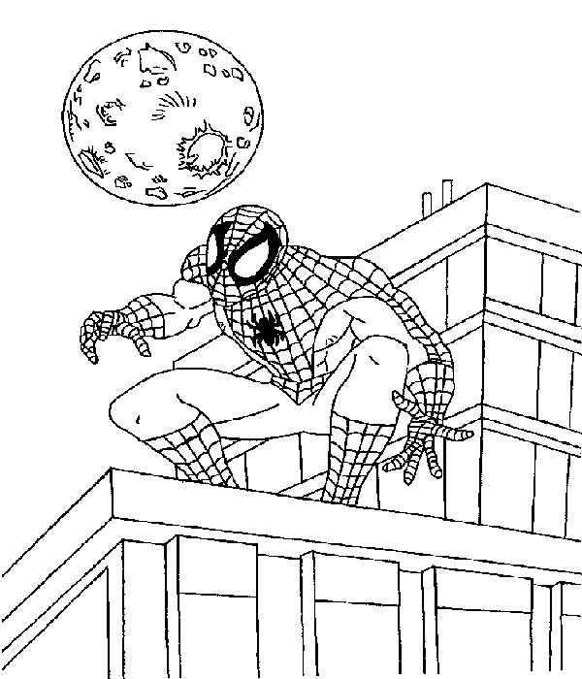
Cela Continue !!!!
Aide Moi STP

 | KM | HM | DAM | M | DM | CM | MM
3,2Km |  |  |  |  |  |  |  | m

 | KM | HM | DAM | M | DM | CM | MM
1/20m |  |  |  |  |  |  |  | Km

 | KM | HM | DAM | M | DM | CM | MM
0,1Km |  |  |  |  |  |  |  | Hm

 | KM | HM | DAM | M | DM | CM | MM
3/5Dm |  |  |  |  |  |  |  | m

 | KM | HM | DAM | M | DM | CM | MM
14Dm |  |  |  |  |  |  |  | Cm

 | KM | HM | DAM | M | DM | CM | MM
7Dm |  |  |  |  |  |  |  | m

 | KM | HM | DAM | M | DM | CM | MM
2/8Dm |  |  |  |  |  |  |  | m

 | KM | HM | DAM | M | DM | CM | MM
1/2Dm |  |  |  |  |  |  |  | m

 | KM | HM | DAM | M | DM | CM | MM
12,25Dm |  |  |  |  |  |  |  | Cm

 | KM | HM | DAM | M | DM | CM | MM
1/8Dm |  |  |  |  |  |  |  | m

 | KM | HM | DAM | M | DM | CM | MM
1,39Dam |  |  |  |  |  |  |  | m

 | KM | HM | DAM | M | DM | CM | MM
1/5Cm |  |  |  |  |  |  |  | m
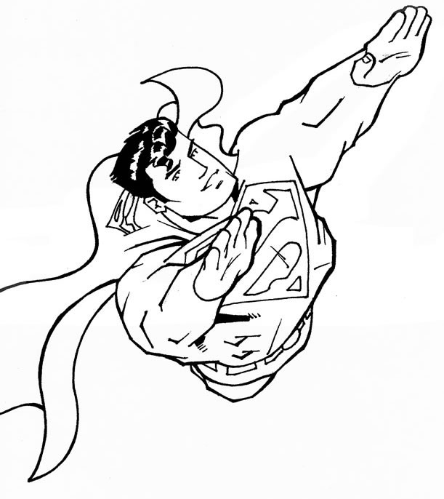
Aide moi aussi ….
Calcule vite et ….. bien !!!
Aide toi du tableau

3m - 2Dm = m
KM | HM | DAM | M | DM | CM | MM

14Hm + 5Dm = m
KM | HM | DAM | M | DM | CM | MM

59m - 2Dm = m
KM | HM | DAM | M | DM | CM | MM

7Dam + 3Km = m
KM | HM | DAM | M | DM | CM | MM

112Dm + 18Hm = m
KM | HM | DAM | M | DM | CM | MM

23Dm + 45Dam + 9Km = m
KM | HM | DAM | M | DM | CM | MM

7Km + 3Dam + 8Dm = m
KM | HM | DAM | M | DM | CM | MM

9,1m + 2Km + 9Dm + 1Km = m
KM | HM | DAM | M | DM | CM | MM

Cela n’est pas terminé !!!
Ah ah ah ah ah
Qui sera le vainqueur !??

 | KM |  | HM |  | DAM |  | M |  | DM |  | CM |  | MM
15Cm |  |  |  |  |  |  |  |  |  |  |  |  |  |  | m
3,4Hm |  |  |  |  |  |  |  |  |  |  |  |  |  |  | Mm
35,5Dam |  |  |  |  |  |  |  |  |  |  |  |  |  |  | Km
356Dm |  |  |  |  |  |  |  |  |  |  |  |  |  |  | Dam
0,5m |  |  |  |  |  |  |  |  |  |  |  |  |  |  | Mm
15M |  |  |  |  |  |  |  |  |  |  |  |  |  |  | Cm
34Km |  |  |  |  |  |  |  |  |  |  |  |  |  |  | Dm
355Mm |  |  |  |  |  |  |  |  |  |  |  |  |  |  | Dam
3,56Km |  |  |  |  |  |  |  |  |  |  |  |  |  |  | Hm
10,5m |  |  |  |  |  |  |  |  |  |  |  |  |  |  | Mm

 | KM | HM | DAM | M | DM | CM | MM
2,05m |  |  |  |  |  |  |  | =20,5.....
85Dam |  |  |  |  |  |  |  | =850.......
63.3Dam |  |  |  |  |  |  |  | =6330....
2Km |  |  |  |  |  |  |  | =2000....
16Mm |  |  |  |  |  |  |  | =1,6......
15Cm |  |  |  |  |  |  |  | =0.15....
96m |  |  |  |  |  |  |  | =960.....

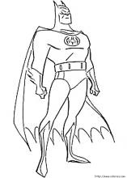

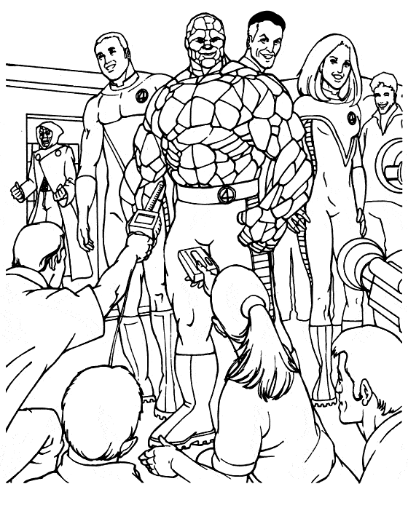
A TOI DE JOUER !!!!!
TU ES FANTASTIQUE
Un SUPER – MEGA - CHAMPION

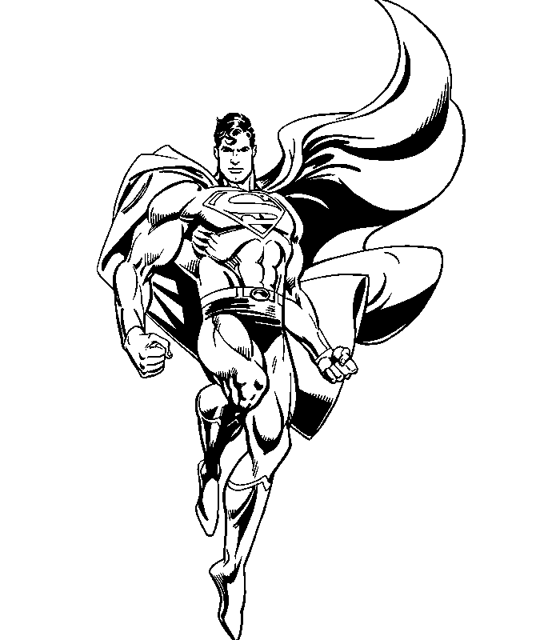

Entoure la plus grande longueur

Classe ici de la plus petite longueur à la plus grande
Classe ici de la plus grande longueur à la plus petite

5Cm | 5Dm | .............. | 1/2m | 51Cm
7Dm | 80Cm |  | 1/4m | 48Cm
36Cm | 3Dm |  | 1/5m | 23Cm
12Dm | 2m |  | 1/2m | 47Cm
6Dm | 61Cm |  | 1/4m | 31Cm

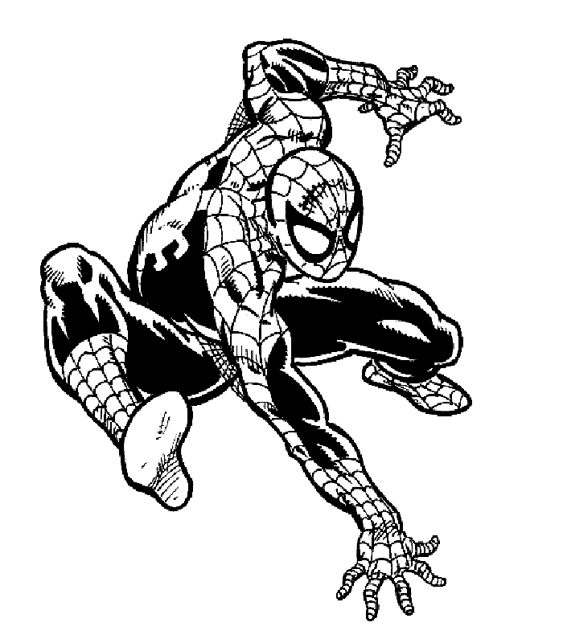
Ecris en m Ecris en Dam
1/2Hm | m |  | 1/2Hm | Dam
7Dam | m |  | 1/4Km | Dam
1/4Hm | m |  | 80m | Dam
2,3Hm | m |  | 3000m | Dam
37Dam | m |  | 175Dm | Dam

½ m = Cm | 4 Cm + Cm = 1Dm | 8Dm - Cm = ½ m
¼ m = Cm | 1/2Dm + Cm = 1 Dm | 3Dm - Cm = 10 Cm
1/10 m = Cm | 30 Cm + Cm = 1 m | 1m – 30Cm = Dm
½ m = Dm | 4Dm + Cm = 1 m | 1m + Dm = 1 ½ m
1/5 m = Dm | ¼ m + Cm = 1m | 7 Dm - Dm = 30 Cm
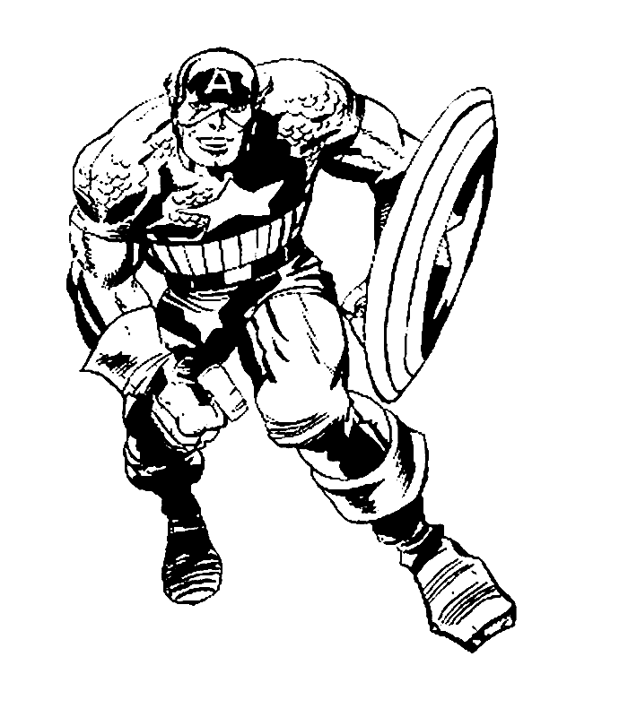

Calcule

1m – 1 Cm = | 1 m + = 105 Cm | 5Dm + = 1m
1m – 10 Cm = | + 2 m = 250Cm | 1m - 10 Dm = Cm
1m – 2 Cm = | 1 m - = 8Dm | 97Cm + Cm = 10Dm
1m – 20 Cm = | 90 Cm - = 8Dm | 4Dm – 37Cm = Cm

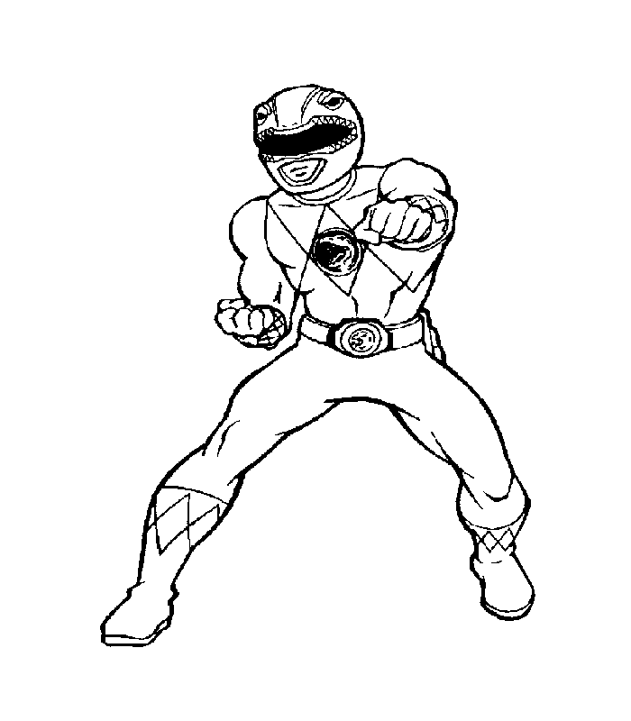ENTOURE LA PLUS GRANDE MESURE

12Dm 7Dm | 12Cm 12Dm | 5m 50Cm
25Cm 18Cm | 15Dm 20Dm | 20Dm 205 Cm
14Dm 14Cm | 12Cm 2Dm | 1Dm 75 Cm
8Dm 78Cm | 45Cm 4Dm | 1Dm 20Cm

