Prénom : Date :

Le climat de l’Europe

1) Carte de l’Europe :

L’Europe se situe en zone __________________.
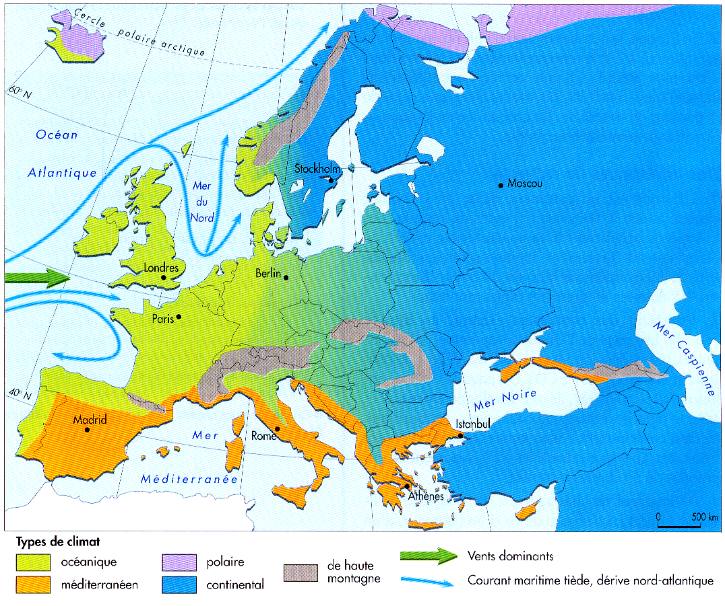

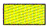
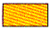

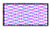


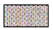

2) Description des climats :

Climat océanique : ____________________________________________
____________________________________________________________
Exemple : ____________________________________________________

Climat méditerranéen : _______________________________________
____________________________________________________________
Exemple : ____________________________________________________

Climat polaire : ______________________________________________
____________________________________________________________
Exemple : ____________________________________________________

Climat montagnard : __________________________________________
____________________________________________________________
Exemple : ____________________________________________________

Climat continental : __________________________________________
____________________________________________________________
Exemple : ____________________________________________________

3) Cultures et végétation :

Climat océanique : ____________________________________________
____________________________________________________________


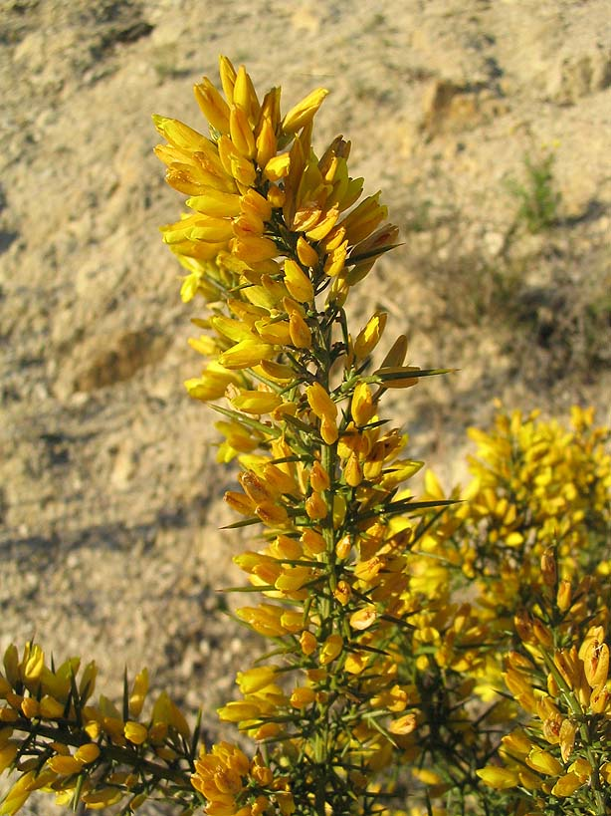

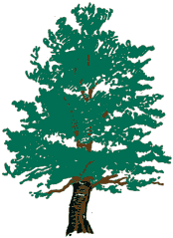
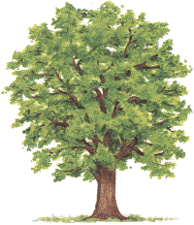

Climat méditerranéen : _______________________________________
____________________________________________________________
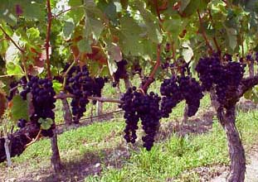







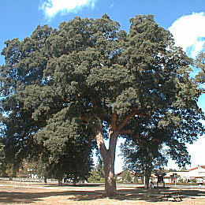
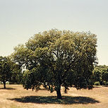

Climat polaire : ______________________________________________

Climat montagnard : __________________________________________
____________________________________________________________


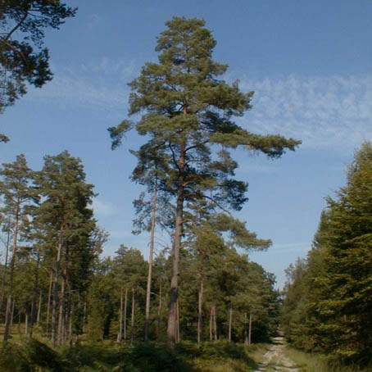

Climat continental : __________________________________________
____________________________________________________________

