 |  |  |  |  |  | 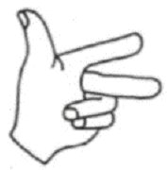 |  | 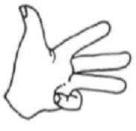 |  | 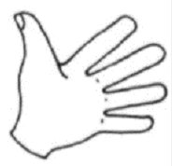
1 |  |  | 2 |  |  | 3 |  | 4 |  | 5
un |  |  | deux |  |  | trois |  | quatre |  | cinq
 |  |  |  |  |  | 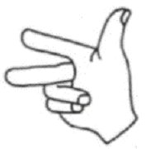 |  | 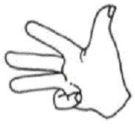 |  | 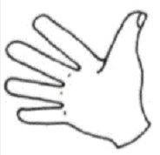
6 |  |  | 7 |  |  | 8 |  | 9 |  | 10
six |  |  | sept |  |  | huit |  | neuf |  | dix

