a – e – i – o - u
Entoure les lettres qu’on entend  dans les mots suivants !

a – e – i – o – u a – e – i - o – u a – e – i – o – u
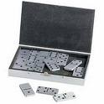
a – e – i – o –u a – e – i – o – u a – e – i – o – u

a –e – i – o – u a – e – i – o – u a – e – i –o – u

a – e – i – o – u a – e – i – o – u a – e – i – o – u

a – e – i – o – u a – e – i – o – u a – e – i – o - u

