Prénom :…………………………… Date :…………………………………………..
Calcul mental : CDU+CDU 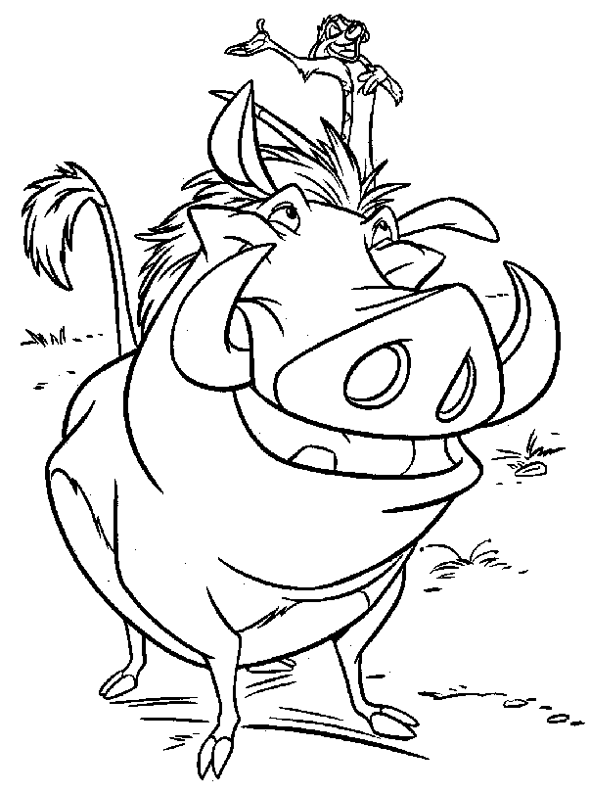

Effectue les exercices suivants en les décomposant.

1) 353 + 235 = (300+200)+(50+30)+(3+5)=588
2) 512 + 341 = _________________________________________
3) 246 + 123 = _________________________________________
4) 444 + 452 = _________________________________________
6) 628 + 141 =__________________________________________
7) 236 + 545 = _________________________________________
8) 726 + 139 = _________________________________________
9) 575 + 218= _________________________________________
10) 736 + 111= _________________________________________
11) 581 + 217= _________________________________________
12) 654 + 223 = _________________________________________
13) 127 + 682 =_________________________________________
14) 467 + 326 =_________________________________________
15) 189 + 314 =_________________________________________
16) 247 + 221=_________________________________________
17) 364+215=_________________________________________
18) 416 + 173=_________________________________________
19) 547 + 365 =_________________________________________
20) 315 + 221=_________________________________________

