Mesures de Longueur
A toi de Jouer !!!

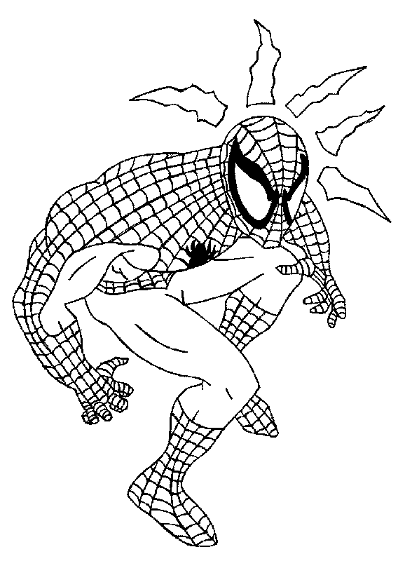

Donc je la lance à ??? m
Je lance ma toile à 1hm

Aide-toi du tableau pour m’éviter de tomber !!!

 | KM | HM | DAM | M | DM | CM | MM
1Hm |  |  |  |  |  |  |  | m

 | KM | HM | DAM | M | DM | CM | MM
5Hm |  |  |  |  |  |  |  | m

 | KM | HM | DAM | M | DM | CM | MM
3Dam |  |  |  |  |  |  |  | m

 | KM | HM | DAM | M | DM | CM | MM
80Hm |  |  |  |  |  |  |  | m

 | KM | HM | DAM | M | DM | CM | MM
3Hm |  |  |  |  |  |  |  | Dam

 | KM | HM | DAM | M | DM | CM | MM
70Dam |  |  |  |  |  |  |  | Hm

 | KM | HM | DAM | M | DM | CM | MM
3Km |  |  |  |  |  |  |  | m

 | KM | HM | DAM | M | DM | CM | MM
16Km |  |  |  |  |  |  |  | Dam
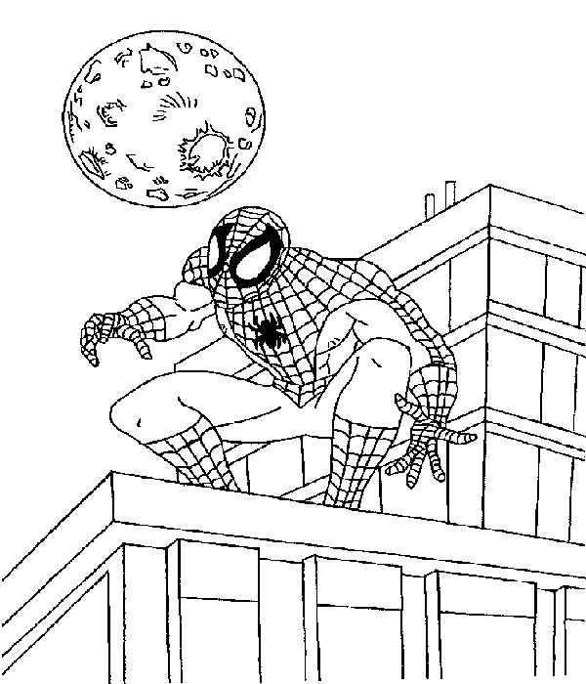
Ça continue !!!!
Aide-moi STP

 | KM | HM | DAM | M | DM | CM | MM
3Km |  |  |  |  |  |  |  | m

 | KM | HM | DAM | M | DM | CM | MM
20m |  |  |  |  |  |  |  | dam

 | KM | HM | DAM | M | DM | CM | MM
1Km |  |  |  |  |  |  |  | Hm

 | KM | HM | DAM | M | DM | CM | MM
310Dm |  |  |  |  |  |  |  | m

 | KM | HM | DAM | M | DM | CM | MM
14Dm |  |  |  |  |  |  |  | Cm

 | KM | HM | DAM | M | DM | CM | MM
75Dm |  |  |  |  |  |  |  | m

 | KM | HM | DAM | M | DM | CM | MM
830Dm |  |  |  |  |  |  |  | m

 | KM | HM | DAM | M | DM | CM | MM
200Dm |  |  |  |  |  |  |  | m

 | KM | HM | DAM | M | DM | CM | MM
12Dm |  |  |  |  |  |  |  | Cm

 | KM | HM | DAM | M | DM | CM | MM
50Dm |  |  |  |  |  |  |  | Dam

 | KM | HM | DAM | M | DM | CM | MM
305Dam |  |  |  |  |  |  |  | m

 | KM | HM | DAM | M | DM | CM | MM
80Cm |  |  |  |  |  |  |  | m
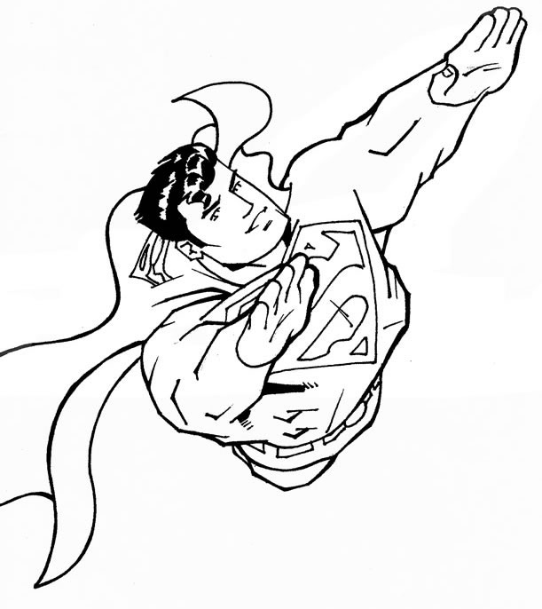
Aide-moi aussi ….
Calcule vite et ….. bien !!!
Aide-toi du tableau

1m - 2dm = ………… dm
KM | HM | DAM | M | DM | CM | MM

1hm + 5dam = ………….. m
KM | HM | DAM | M | DM | CM | MM

1m - ...……. dm = 40 cm
KM | HM | DAM | M | DM | CM | MM

1000 mm + …………… cm = 3 m
KM | HM | DAM | M | DM | CM | MM

………… dm - 60 cm = 3 dm
KM | HM | DAM | M | DM | CM | MM

………… km - 5 hm = 50 dam
KM | HM | DAM | M | DM | CM | MM

7km + 3hm + 8dam = …………... m
KM | HM | DAM | M | DM | CM | MM

8hm + 3dam + 1hm + 7 dam = …………… km
KM | HM | DAM | M | DM | CM | MM

Ce n’est pas terminé !!!
Qui sera le vainqueur !??
Hahahahahaha….

 | KM | HM | DAM | M | DM | CM | MM
15 cm |  |  |  |  |  |  |  | mm
34 hm |  |  |  |  |  |  |  | m
20 dam |  |  |  |  |  |  |  | km
356 dm |  |  |  |  |  |  |  | m
0,5m |  |  |  |  |  |  |  | cm
15m |  |  |  |  |  |  |  | cm
34km |  |  |  |  |  |  |  | dm
355mm |  |  |  |  |  |  |  | cm
3,5km |  |  |  |  |  |  |  | hm
10,5m |  |  |  |  |  |  |  | mm

 | KM | HM | DAM | M | DM | CM | MM
2,5 m |  |  |  |  |  |  |  | =25.........
85 dam |  |  |  |  |  |  |  | =850.........
63,5 dam |  |  |  |  |  |  |  | =6’350.......
2 km |  |  |  |  |  |  |  | =2’000.......
16 mm |  |  |  |  |  |  |  | =1,6.........
15 cm |  |  |  |  |  |  |  | =0,15.......
96 m |  |  |  |  |  |  |  | =960........

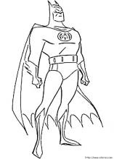

A TOI DE JOUER !!!!!
TU ES FANTASTIQUE
Un SUPER – MEGA – CHAMPION
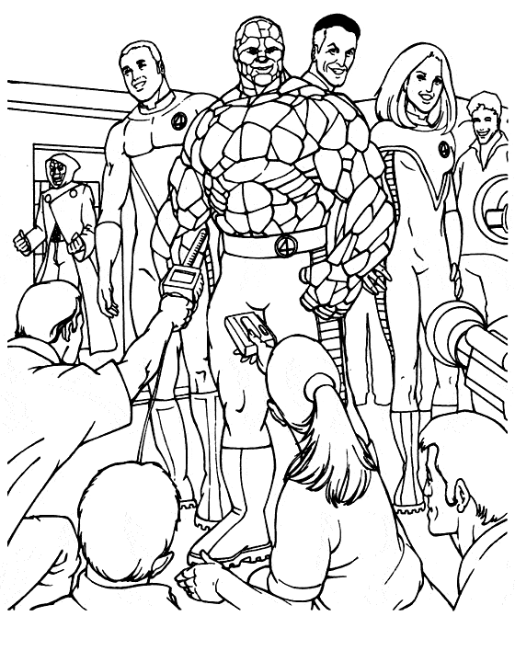

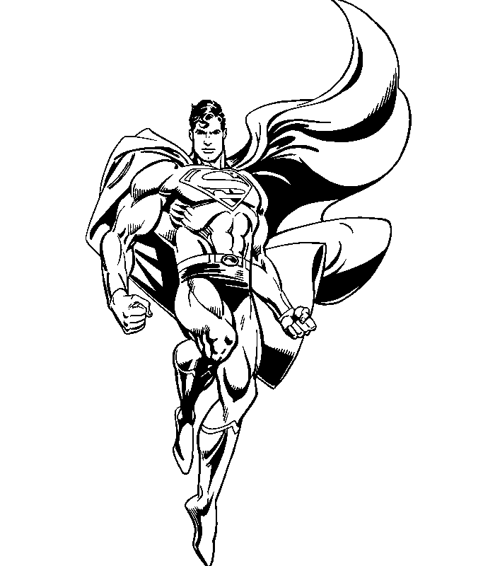

Entoure la plus grande longueur

Classe ici de la plus petite longueur à la plus grande
Classe ici de la plus grande longueur à la plus petite

5 cm | 5 dm | .............. | 5 m | 51cm
7 dm | 80 cm |  | 4dm | 41cm
36 cm | 3 dm |  | 50 m | 510 cm
12 dm | 2 m |  | 7 dm | 750 mm
6 cm | 61 mm |  | 3 m | 31 dm

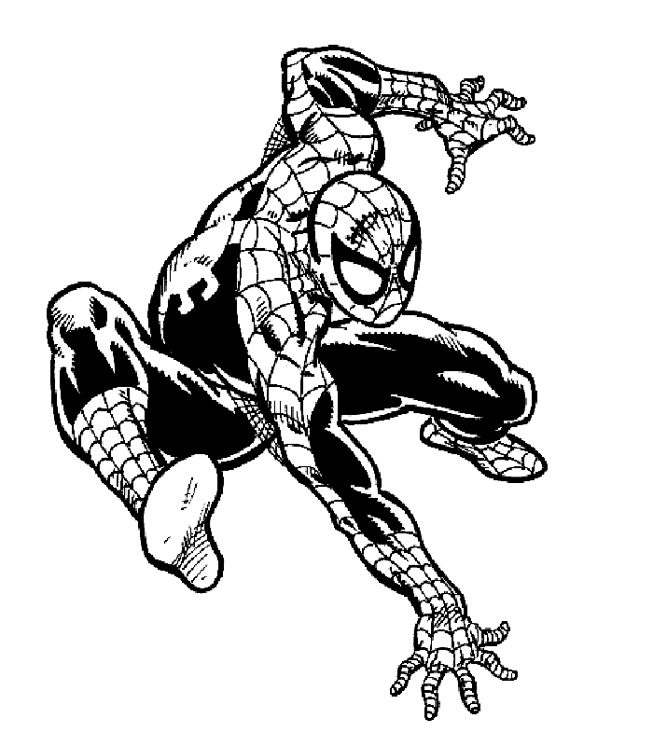
Ecris en m Ecris en dam
2 hm | m |  | 12 hm | dam
7 dm | m |  | 4 km | dam
400 cm | m |  | 80 m | dam
2,3dam | m |  | 3,6 km | dam
9,7 km | m |  | 150 dm | dam

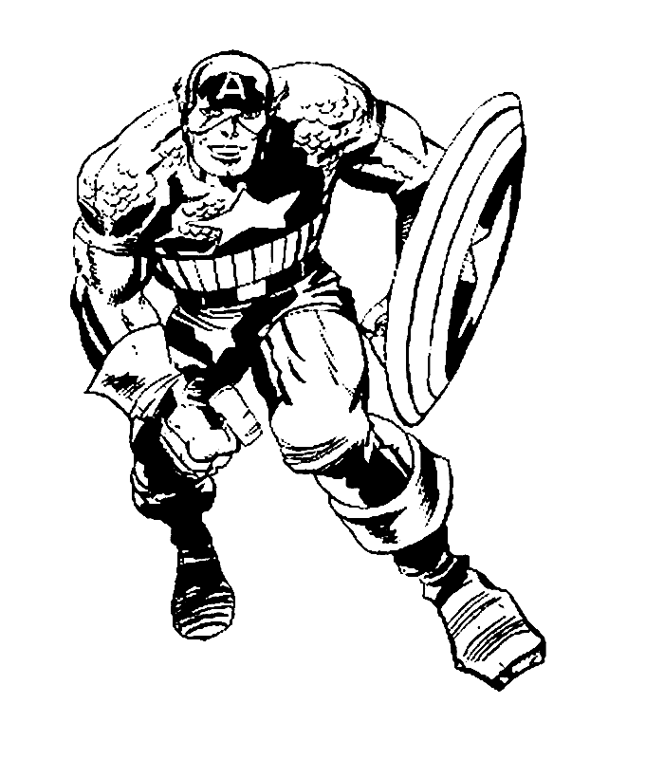

4 cm + cm = 1 dm | 8 dm - cm = 5 dm
5 dm + cm = 10 dm | 3 dm - cm = 10 cm
30 cm + dm = 1 m | 1 m – 30 cm = dm
9 dm + cm = 1 m | 1 m + dm = 15 dm
2 dm + cm = 1 m | 7 dm - dm = 30 cm
Calcule

1m – 1 cm = cm | 1 m + dm = 150 cm | 5Dm + cm = 1m
1m – 1 dm = cm | cm + 2 m = 25 dm | 1m – 10 dm = cm
1m – 2 cm = cm | 1 m - cm = 8 dm | 60 cm + dm = 1 m
1m – 20 cm = dm | 90 cm - dm = 8 dm | 4 dm – 30 cm = mm

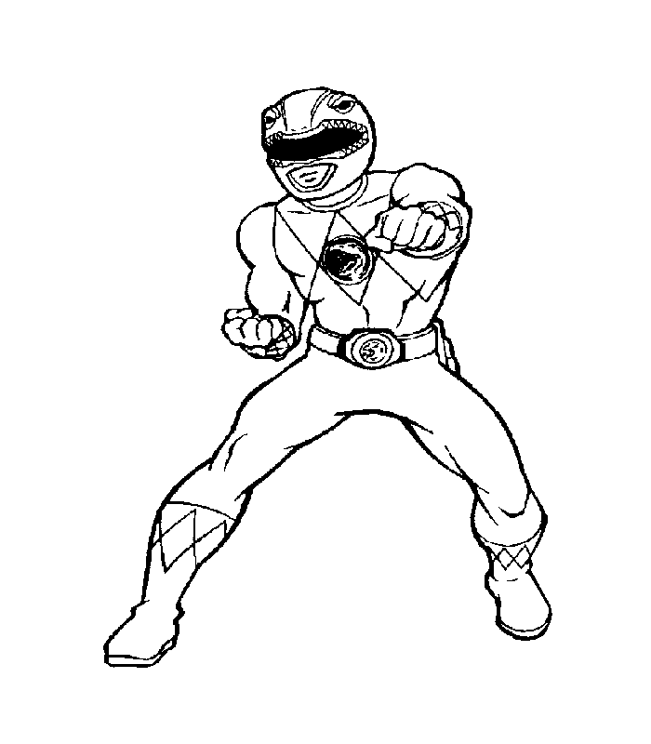ENTOURE LA PLUS GRANDE MESURE

12 dm 120 mm | 21 cm 12 dm | 5 m 50 cm
25 km 15 hm | 20 hm 210 m | 20 dam 205 m
40 m 14 dam | 50 m 6 dm | 8 dm 75 cm
8 dm 78 cm | 4 dm 45 cm | 190 mm 20 cm

