Les tables de multiplication vues par famille

2 x
4 x
8 x

2 x 0 = 0  2 x 1 = 2  2 x 2 = 4  2 x 3 = 6  2 x 4 = 8  2 x 5 = 10  2 x 6 = 12  2 x 7 = 14  2 x 8 = 16  2 x 9 = 18  2 x 10 = 20 | x 2  : 2 | 4 x 0 = 0  4 x 1 = 4  4 x 2 = 8  4 x 3 = 12  4 x 4 = 16  4 x 5 = 20  4 x 6 = 24  4 x 7 = 28  4 x 8 = 32  4 x 9 = 36  4 x 10 = 40 | x 2  : 2 | 8 x 0 = 0  8 x 1 = 8  8 x 2 = 16  8 x 3 = 24  8 x 4 = 32  8 x 5 = 40  8 x 6 = 48  8 x 7 = 56  8 x 8 = 64  8 x 9 = 72  8 x 10 = 80

Tu recherches : 8 x 6 = ? Tu penses à 4 x 6 = … puis réponse x 2

3 x
6 x

6 x 6 = ?
Tu cherches la moitié :
3 x …

3 x 0 = 0  3 x 1 = 3  3 x 2 = 6  3 x 3 = 9  3 x 4 = 12  3 x 5 = 15  3 x 6 = 18  3 x 7 = 21  3 x 8 = 24  3 x 9 = 27  3 x 10 = 30 | x 2  : 2 | 6 x 0 = 0  6 x 1 = 6  6 x 2 = 12  6 x 3 = 18  6 x 4 = 24  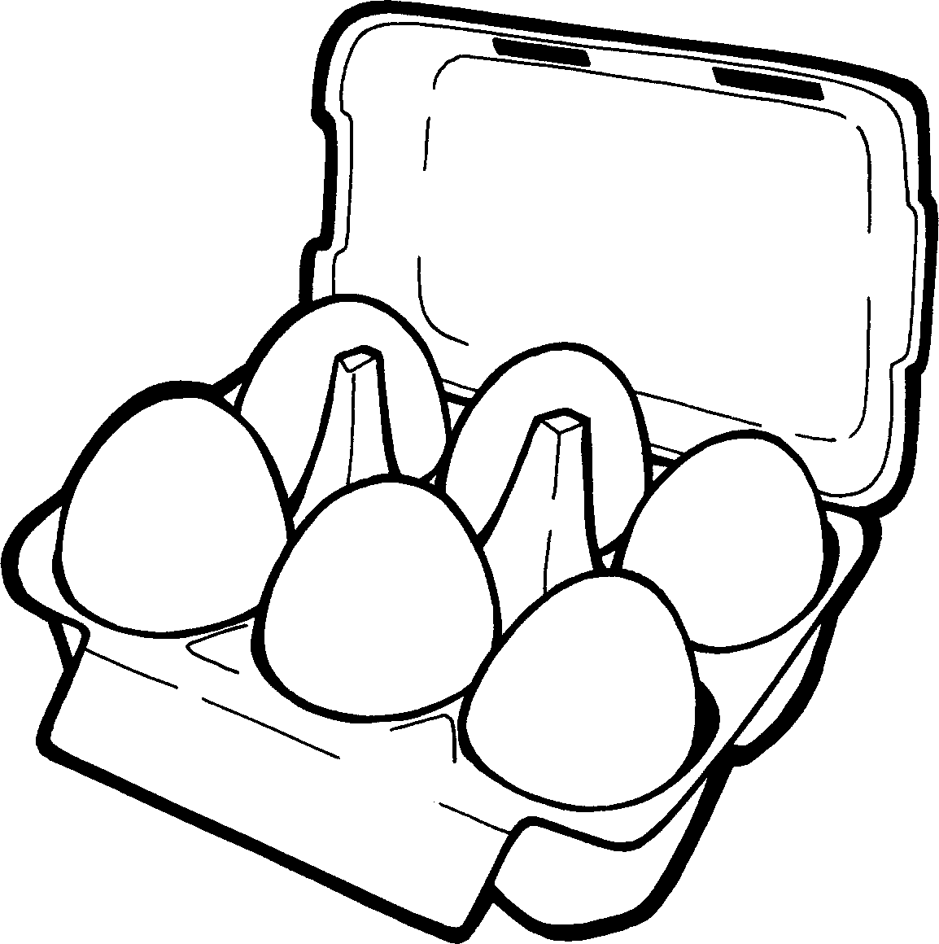  6 x 5 = 30  6 x 6 = 36  6 x 7 = 42  3 x 6 = 18  3 x 6 = 18  +  6 x 8 = 48  6 x 9 = 54  = 2 x 18 = 36  6 x 10 = 60

La table par 5… Facile ! Tu penses à l’horloge …
5 x

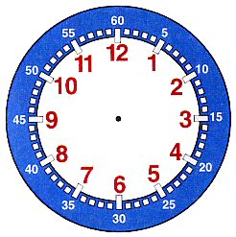
5 x 0 = 0
5 x 1 = 5
5 x 2 = 10
2 x 5 = 10
10 x 5 = 50
5 x 3 = 15
3 x 5 = 15
9 x 5 = 45
5 x 4 = 20
5 x 5 = 25
4 x 5 = 20
8 x 5 = 40
5 x 6 = 30
5 x 7 = 35
5 x 5 = 25
7 x 5 = 35
5 x 8 = 40
6 x 5 = 30
5 x 9 = 45
5 x 10 = 50

Calculs à retenir par
9 x 7 = 63

70
(10 x 7) - 7

7 x 7 = 49

42
(6 x 7) + 7

9 x 9 = 81

90
(10 x 9) - 9

