
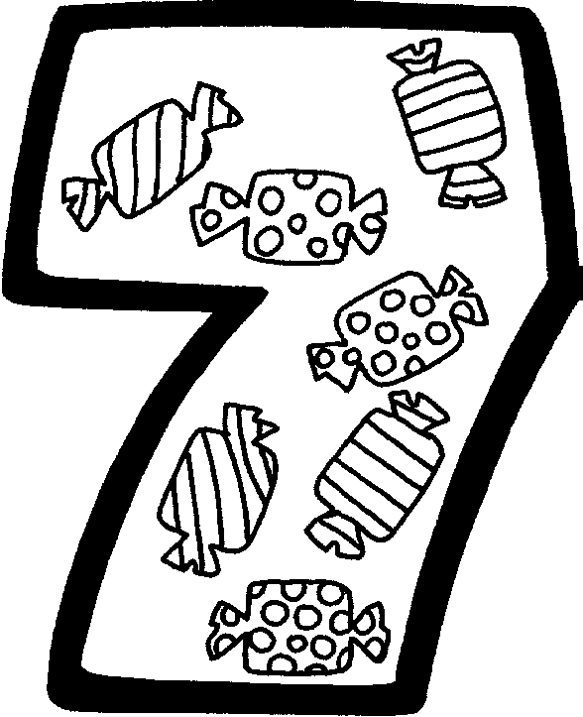
Procédés de calcul : je calcule vite et bien.
Lundi
U+U  1+1=  2+1=  3+1=  4+1=  5+1= | D+U  10+1=  20+1=  30+1=  40+1=  50+1= | U+D  1+10=  1+20=  1+30=  1+40=  1+50= | D+D  10+10=  20+10=  30+10=  40+10=  50+10=

Mardi
U-U  1-1=  2-1=  3-1=  4-1=  5-1= | DU-U  11-1=  21-1=  31-1=  41-1=  51-1= | DU+D  11+10=  11+20=  11+30=  11+40=  11+50= | D+DU  10+11=  20+11=  30+11=  40+11=  50+11=

Mercredi
DU+U  11+1=  12+1=  13+1=  14+1=  15+1= | DU+U  16+1=  21+1=  31+1=  41+1=  51+1= | DU+D  21+10=  21+20=  21+30=  21+40=  21+50= | D+D  10+20=  20+20=  30+20=  40+20=  50+20=

Jeudi
U-U  9-1=  8-1=  7-1=  6-1=  5-1= | DU-U  12-2=  22-2=  32-2=  42-2=  52-2= | DU+D  31+10=  31+20=  31+40=  31+50=  31+60= | D+DU  10+21=  20+31=  30+41=  40+41=  50+21=

Vendredi
U+U  9+1=  8+1=  7+1=  6+1=  5+2= | DU-U  14-2=  24-2=  34-2=  44-2=  54-2= | DU+D  33+20=  31+20=  39+40=  44+50=  29+60= | D+DU  10+55=  20+44=  30+66=  40+44=  50+22=

