Prénom : ________________________ N° : ______ Date : _______________ Géographie

**MOTS CROISES : LES CAPITALES EUROPEENNES**

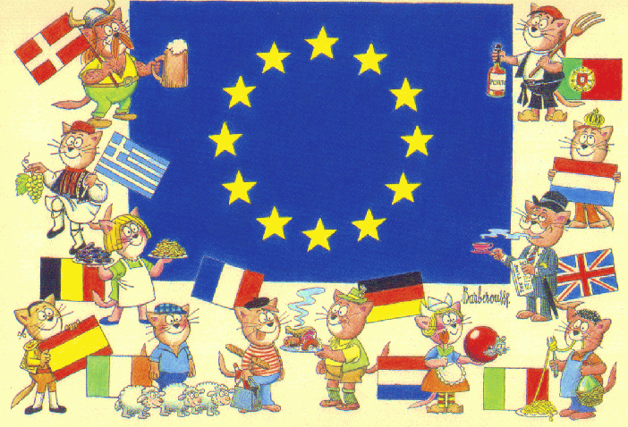

|  |  |  |  |  |  |  |  |  |  |  |  |  |  |  |  |  |  |  |  |  |  |  |  |
| --- | --- | --- | --- | --- | --- | --- | --- | --- | --- | --- | --- | --- | --- | --- | --- | --- | --- | --- | --- | --- | --- | --- | --- |
|  |  |  |  |  |  |  |  |  |  |  |  |  |  |  |  |  |  | 3 |  |  |  |  |  |
|  |  |  |  |  |  |  |  |  |  |  | 1 | C | O | P | E | N | H | A | G | U | E |  |  |
|  |  |  |  |  |  |  |  |  |  |  |  |  |  | 2 |  |  |  | M |  |  |  |  |  |
|  |  |  |  |  |  |  |  |  |  |  |  | 5 | 4 | P | A | R | I | S |  |  |  |  |  |
|  |  |  |  |  |  |  |  |  | 10 |  |  | N |  | R |  |  |  | T |  |  |  |  |  |
|  | 14 |  |  |  |  |  | 11 |  | B | 9 | R | I | G | A | 6 | V | I | E | N | N | E |  |  |
|  | B |  |  |  |  |  | L |  | E |  |  | C |  | G |  |  |  | R |  |  |  |  |  |
|  | U |  |  | 12 |  |  | U |  | R |  |  | O |  | U |  |  |  | D |  |  |  | 8 |  |
|  | C |  | 13 | B | R | U | X | E | L | L | E | S |  | E |  | 7 | M | A | D | R | I | D |  |
|  | A |  |  | R |  |  | E |  | I |  |  | I |  |  |  |  |  | M |  |  |  | U |  |
|  | R |  |  | A |  |  | M |  | N |  |  | E |  |  |  |  |  |  |  |  |  | B |  |
|  | E |  |  | T |  |  | B |  |  |  |  |  |  |  |  |  |  |  |  |  |  | L |  |
| 15 | S | O | F | I | A |  | O |  |  |  |  |  |  |  |  |  |  |  |  |  |  | I |  |
|  | T |  |  | S |  |  | U |  | 20 |  |  |  |  |  |  |  |  |  |  |  |  | N |  |
|  |  |  |  | L |  |  | R | 27 | V | A | R | S | O | V | I | E |  | 22 |  |  |  |  |  |
|  |  |  |  | A |  |  | G |  | I |  |  |  |  |  |  |  |  | L |  |  |  |  |  |
|  |  |  |  | V | 26 |  |  | 25 | L | J | B | U | B | L | J | A | N | A |  |  |  |  |  |
|  |  | 16 | T | A | L | L | I | N | N |  |  |  |  |  | 21 |  |  | V |  |  |  |  |  |
|  |  |  |  |  | O |  |  |  | I |  |  |  |  |  | S |  |  | A |  |  |  |  |  |
|  |  |  |  |  | N |  | 19 | B | U | D | A | P | E | S | T |  |  | L |  |  |  |  |  |
|  |  |  |  |  | D |  |  |  | S |  |  |  |  |  | O |  |  | E |  |  |  |  |  |
|  |  |  |  |  | R |  | 18 |  |  |  |  |  |  |  | C |  |  | T |  |  |  |  |  |
|  |  |  |  |  | E |  | R |  |  |  |  |  |  |  | K |  |  | T |  |  |  |  |  |
|  |  | 17 | L | I | S | B | O | N | N | E |  | 23 | A | T | H | E | N | E | S |  |  |  |  |
|  |  |  |  |  |  |  | M |  |  |  |  |  |  |  | O |  |  |  |  |  |  |  |  |
|  |  |  |  |  |  |  | E |  |  |  |  | 24 | H | E | L | S | I | N | K | I |  |  |  |
|  |  |  |  |  |  |  |  |  |  |  |  |  |  |  | M |  |  |  |  |  |  |  |  |

**Les pays européens :**

|  |  |  |
| --- | --- | --- |
| 1. Danemark 2. République Tchèque 3. Pays-Bas 4. France 5. Chypre 6. Autriche 7. Espagne 8. Irlande 9. Lettonie | 1. Allemagne 2. Grand Duché du Luxembourg 3. Slovaquie 4. Belgique 5. Roumanie 6. Bulgarie 7. Estonie 8. Portugal 9. Italie | 1. Hongrie 2. Lituanie 3. Suède 4. Malte 5. Grèce 6. Finlande 7. Slovénie 8. Royaume-Unis 9. Pologne |

Prénom : ________________________ N° : ______ Date : _______________ Géographie

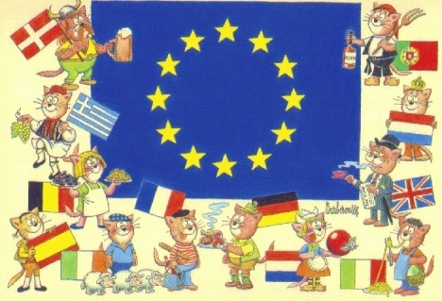**MOTS CROISES : LES CAPITALES EUROPEENNES**

|  |  |  |  |  |  |  |  |  |  |  |  |  |  |  |  |  |  |  |  |  |  |  |  |
| --- | --- | --- | --- | --- | --- | --- | --- | --- | --- | --- | --- | --- | --- | --- | --- | --- | --- | --- | --- | --- | --- | --- | --- |
|  |  |  |  |  |  |  |  |  |  |  |  |  |  |  |  |  |  | 3 |  |  |  |  |  |
|  |  |  |  |  |  |  |  |  |  |  | 1 |  |  |  |  |  |  |  |  |  |  |  |  |
|  |  |  |  |  |  |  |  |  |  |  |  |  |  | 2 |  |  |  |  |  |  |  |  |  |
|  |  |  |  |  |  |  |  |  |  |  |  | 5 | 4 |  |  |  |  |  |  |  |  |  |  |
|  |  |  |  |  |  |  |  |  | 10 |  |  |  |  |  |  |  |  |  |  |  |  |  |  |
|  | 14 |  |  |  |  |  | 11 |  |  | 9 |  |  |  |  | 6 |  |  |  |  |  |  |  |  |
|  |  |  |  |  |  |  |  |  |  |  |  |  |  |  |  |  |  |  |  |  |  |  |  |
|  |  |  |  | 12 |  |  |  |  |  |  |  |  |  |  |  |  |  |  |  |  |  | 8 |  |
|  |  |  | 13 |  |  |  |  |  |  |  |  |  |  |  |  | 7 |  |  |  |  |  |  |  |
|  |  |  |  |  |  |  |  |  |  |  |  |  |  |  |  |  |  |  |  |  |  |  |  |
|  |  |  |  |  |  |  |  |  |  |  |  |  |  |  |  |  |  |  |  |  |  |  |  |
|  |  |  |  |  |  |  |  |  |  |  |  |  |  |  |  |  |  |  |  |  |  |  |  |
| 15 |  |  |  |  |  |  |  |  |  |  |  |  |  |  |  |  |  |  |  |  |  |  |  |
|  |  |  |  |  |  |  |  |  | 20 |  |  |  |  |  |  |  |  |  |  |  |  |  |  |
|  |  |  |  |  |  |  |  | 27 |  |  |  |  |  |  |  |  |  | 22 |  |  |  |  |  |
|  |  |  |  |  |  |  |  |  |  |  |  |  |  |  |  |  |  |  |  |  |  |  |  |
|  |  |  |  |  | 26 |  |  | 25 |  |  |  |  |  |  |  |  |  |  | [http://www.coloriage.tv/32nb/drapeau-union-europeenne.gif](http://www.coloriage.tv/drapeau-union-europeenne-coloriage) |  |  |  |  |
|  |  | 16 |  |  |  |  |  |  |  |  |  |  |  |  | 21 |  |  |  |  |  |  |  |  |
|  |  |  |  |  |  |  |  |  |  |  |  |  |  |  |  |  |  |  |  |  |  |  |  |
|  |  |  |  |  |  |  | 19 |  |  |  |  |  |  |  |  |  |  |  |  |  |  |  |  |
|  |  |  |  |  |  |  |  |  |  |  |  |  |  |  |  |  |  |  |  |  |  |  |  |
|  |  |  |  |  |  |  | 18 |  |  |  |  |  |  |  |  |  |  |  |  |  |  |  |  |
|  |  |  |  |  |  |  |  |  |  |  |  |  |  |  |  |  |  |  |  |  |  |  |  |
|  |  | 17 |  |  |  |  |  |  |  |  |  | 23 |  |  |  |  |  |  |  |  |  |  |  |
|  |  |  |  |  |  |  |  |  |  |  |  |  |  |  |  |  |  |  |  |  |  |  |  |
|  |  |  |  |  |  |  |  |  |  |  |  | 24 |  |  |  |  |  |  |  |  |  |  |  |
|  |  |  |  |  |  |  |  |  |  |  |  |  |  |  |  |  |  |  |  |  |  |  |  |

**Les pays européens :**

|  |  |  |
| --- | --- | --- |
| 1. Danemark 2. République Tchèque 3. Pays-Bas 4. France 5. Chypre 6. Autriche 7. Espagne 8. Irlande 9. Lettonie | 1. Allemagne 2. Grand Duché du Luxembourg 3. Slovaquie 4. Belgique 5. Roumanie 6. Bulgarie 7. Estonie 8. Portugal 9. Italie | 1. Hongrie 2. Lituanie 3. Suède 4. Malte 5. Grèce 6. Finlande 7. Slovénie 8. Royaume-Unis 9. Pologne |