|  |  |  |  |
| --- | --- | --- | --- |
| 1.  [Click to view](http://classroomclipart.com/cgi-bin/kids/imageFolio.cgi?action=view&link=Dinosaurs&image=01-08-08_23M_a.jpg&img=&tt=) | 2.  [http://tbn2.google.com/images?q=tbn:tiICbhTKecPYRM:http://thecanadianexperience.unblog.fr/files/2008/11/poppy300.jpg](http://images.google.ca/imgres?imgurl=http://thecanadianexperience.unblog.fr/files/2008/11/poppy300.jpg&imgrefurl=http://thecanadianexperience.unblog.fr/2008/11/03/les-coquelicots-fleurissent-au-canada/&usg=__LGkeQBcQv63nkbXxtJimw6zRMhw=&h=363&w=300&sz=19&hl=fr&start=6&tbnid=tiICbhTKecPYRM:&tbnh=121&tbnw=100&prev=/images%3Fq%3Dpoppy%26gbv%3D2%26hl%3Dfr) | 3.  [Click to view](http://classroomclipart.com/cgi-bin/kids/imageFolio.cgi?action=view&link=History/Hieroglyphs&image=hieroglyphs766A.gif&img=&tt=) | 4.  [Click to view](http://classroomclipart.com/cgi-bin/kids/imageFolio.cgi?action=view&link=History/Age_of_Exploration&image=jacques_cartier_180-w.jpg&img=6&tt=) |
| 5.  [Click to view](http://classroomclipart.com/cgi-bin/kids/imageFolio.cgi?action=view&link=History/Ancient_Civilizations/Ancient_Greece/Illustrations&image=WP4_153partheonA.jpg&img=18&tt=) | 6.  [Click to view](http://classroomclipart.com/cgi-bin/kids/imageFolio.cgi?action=view&link=History/Inventions&image=microwave.jpg&img=6&tt=) | 7.  [http://tbn2.google.com/images?q=tbn:6k1ORrcpVHBGUM:http://www.educol.net/fr-images-coloriages-colorier-photo-soldats-romains-p3019.jpg](http://images.google.ca/imgres?imgurl=http://www.educol.net/fr-images-coloriages-colorier-photo-soldats-romains-p3019.jpg&imgrefurl=http://www.educol.net/fr-images-coloriages-colorier-photo-soldats-romains-i3019.html&usg=__eg9TajG-w3K_3idfUl6Jf-MXGjM=&h=874&w=618&sz=115&hl=fr&start=10&tbnid=6k1ORrcpVHBGUM:&tbnh=146&tbnw=103&prev=/images%3Fq%3Dromains%26gbv%3D2%26hl%3Dfr) | 8.  [http://tbn1.google.com/images?q=tbn:r7NlvAe6fPiwTM:http://blogs.citypages.com/sports/Vikings.jpg](http://images.google.ca/imgres?imgurl=http://blogs.citypages.com/sports/Vikings.jpg&imgrefurl=http://blogs.citypages.com/sports/2008/09/forbes_to_vikin.php&usg=__k1Sl2dtKKUkInbMMOPulGZ4JVAg=&h=480&w=320&sz=71&hl=fr&start=18&tbnid=r7NlvAe6fPiwTM:&tbnh=129&tbnw=86&prev=/images%3Fq%3Dvikings%26gbv%3D2%26hl%3Dfr)**[drakar](http://www.educol.net/fr-images-coloriages-colorier-photo-drakar-i9874.html)** |
| 9.  [Click to view](http://classroomclipart.com/cgi-bin/kids/imageFolio.cgi?action=view&link=History/Age_of_Exploration&image=discovery_iceland_87w.jpg&img=18&tt=) | 10.  [http://tbn2.google.com/images?q=tbn:Q_uGPFxLwnJa_M:http://www.musee-ours-cavernes.com/fete-prehistorique/images/deroulement-fete/homme%2520pr%C3%A9historique.copy%2520iris.solutions.jpg](http://images.google.ca/imgres?imgurl=http://www.musee-ours-cavernes.com/fete-prehistorique/images/deroulement-fete/homme%2520pr%C3%A9historique.copy%2520iris.solutions.jpg&imgrefurl=http://www.musee-ours-cavernes.com/fete-prehistorique/index.html&usg=__uU6gs5A8O_nI-aucQIlE4DefvLA=&h=700&w=555&sz=42&hl=fr&start=33&tbnid=Q_uGPFxLwnJa_M:&tbnh=140&tbnw=111&prev=/images%3Fq%3Dpr%25C3%25A9historique%26gbv%3D2%26ndsp%3D18%26hl%3Dfr%26sa%3DN%26start%3D18) | 11.  [Click to view](http://classroomclipart.com/cgi-bin/kids/imageFolio.cgi?action=view&link=History/Middle_Ages/Castles&image=MRL_036AB.jpg&img=&tt=) | 12.  [Click to view](http://classroomclipart.com/cgi-bin/kids/imageFolio.cgi?action=view&link=History/Ancient_Civilizations/Ancient_Greece/Illustrations&image=WWPIV_38MedallionA.jpg&img=&tt=) |
| 13.  [http://tbn3.google.com/images?q=tbn:2KDnaomLiSQ-ZM:http://www.glennharris.com.au/catalog/images/Indian%2520Brave.jpg](http://images.google.ca/imgres?imgurl=http://www.glennharris.com.au/catalog/images/Indian%2520Brave.jpg&imgrefurl=http://www.glennharris.com.au/catalog/index.php%3Fmain_page%3Dindex%26cPath%3D32&usg=__PT59PJznvs497K_GCyHzAV7nZlg=&h=481&w=500&sz=17&hl=fr&start=71&tbnid=2KDnaomLiSQ-ZM:&tbnh=125&tbnw=130&prev=/images%3Fq%3Dindians%26gbv%3D2%26ndsp%3D18%26hl%3Dfr%26sa%3DN%26start%3D54) | 14.  [http://tbn1.google.com/images?q=tbn:-_Kl-arusdlEPM:http://www.zeblog.com/blog/uploads/j/jumcreteilabymes/joconde.jpg](http://images.google.ca/imgres?imgurl=http://www.zeblog.com/blog/uploads/j/jumcreteilabymes/joconde.jpg&imgrefurl=http://jumcreteilabymes.zeblog.com/227386-presentation-des-differentes-expositions-au-musee-du-louvre/&usg=__YhOFQQY2fmoANqo10EbBHZvkgp8=&h=540&w=350&sz=43&hl=fr&start=1&tbnid=-_Kl-arusdlEPM:&tbnh=132&tbnw=86&prev=/images%3Fq%3Dleonard%2Bvinci%26gbv%3D2%26hl%3Dfr) | 15.  [http://tbn0.google.com/images?q=tbn:lzNw8mQLmxgZ0M:http://www.lessignets.com/signetsdiane/calendrier/images/avril/27/esclave14.gif](http://images.google.ca/imgres?imgurl=http://www.lessignets.com/signetsdiane/calendrier/images/avril/27/esclave14.gif&imgrefurl=http://www.lessignets.com/signetsdiane/calendrier/avril/27.htm&usg=__9SOs603hEfer8hSD7X5rLFablyE=&h=232&w=207&sz=9&hl=fr&start=14&tbnid=lzNw8mQLmxgZ0M:&tbnh=109&tbnw=97&prev=/images%3Fq%3Desclave%26gbv%3D2%26hl%3Dfr%26sa%3DX) | 16.  [Click to view](http://classroomclipart.com/cgi-bin/kids/imageFolio.cgi?action=view&link=History/Inventions&image=Inventions_1102_071.jpg&img=&tt=) |
| 17.  [http://tbn1.google.com/images?q=tbn:L9c9ElJP0saTTM:http://img10.xooimage.com/files/a/7/7/mayas-201-233753.jpg](http://images.google.ca/imgres?imgurl=http://img10.xooimage.com/files/a/7/7/mayas-201-233753.jpg&imgrefurl=http://lesmysteresdesandes.bestoof.com/index.php&usg=__V_8ZcxlasfwxkRKZjyeb3_pLcE8=&h=260&w=360&sz=30&hl=fr&start=16&tbnid=L9c9ElJP0saTTM:&tbnh=87&tbnw=121&prev=/images%3Fq%3Dmayas%26gbv%3D2%26ndsp%3D18%26hl%3Dfr%26sa%3DN) | 18.  [Click to view](http://classroomclipart.com/cgi-bin/kids/imageFolio.cgi?action=view&link=History/Middle_Ages&image=MP_163.jpg&img=&tt=) | 19.  [Click to view](http://classroomclipart.com/cgi-bin/kids/imageFolio.cgi?action=view&link=History/Hieroglyphs&image=hieroglyphs737A.gif&img=&tt=) | 20.  [http://tbn2.google.com/images?q=tbn:ny1modtt13L0kM:http://www.mairie-allarmont.fr/picsUpload/Eglise.jpg](http://images.google.ca/imgres?imgurl=http://www.mairie-allarmont.fr/picsUpload/Eglise.jpg&imgrefurl=http://www.mairie-allarmont.fr/servlet/ShowInfoSR%3FM%3DS65SFR1RFK6KFL1LF&usg=__-b1griZbt9IBaoy3nudFLi8zfcU=&h=1366&w=1268&sz=244&hl=fr&start=17&tbnid=ny1modtt13L0kM:&tbnh=150&tbnw=139&prev=/images%3Fq%3D%25C3%25A9glise%26gbv%3D2%26hl%3Dfr) |

Date : Nom :

Groupe :

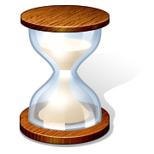LES GRANDES PÉRIODES DE L’HISTOIRE

|  |  |
| --- | --- |
| 1. | 11. |
| 2. | 12. |
| 3. | 13. |
| 4. | 14. |
| 5. | 15. |
| 6. | 16. |
| 7. | 17. |
| 8. | 18. |
| 9. | 19. |
| 10. | 20. |

**[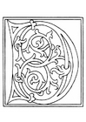](http://www.edupics.com/en-coloring-pictures-pages-photo-01a-alphabet-d-i11251.html)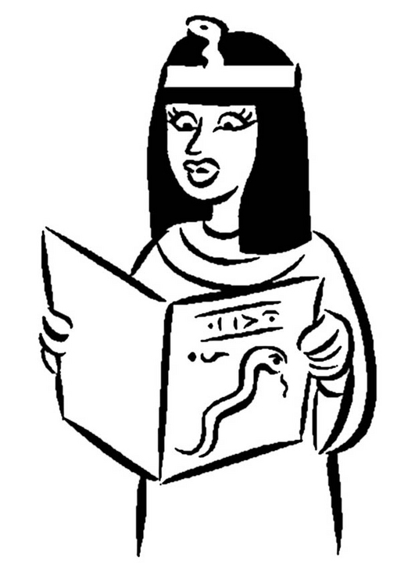[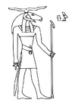](http://www.edupics.com/en-coloring-pictures-pages-photo-chmun-i10150.html)**