**Exercices de lecture**

Prénom : ……………………………………………………

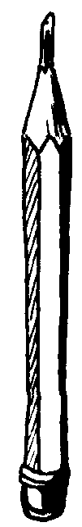

1. **Entoure le bon mot**

|  |  |  |  |
| --- | --- | --- | --- |
| LUNE.BMP | ANE.BMP | EPEE | ILE |
| **lune**  **lume** | **âle**  **âne** | **épue**  **épée** | **île**  **îpe** |
|  |  |  |  |
| Ete | Larme | Ami | ANANAS |
| **été**  **émé** | **lurme**  **larme** | **ami**  **ani** | **ananas**  **anas** |

1. 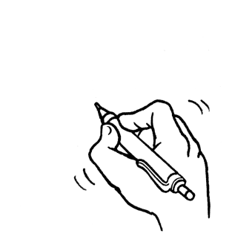**Reconstruis les mots et dessine**

|  |  |  |  |  |
| --- | --- | --- | --- | --- |
| para |  |  | mi |  |
| nar |  |  | pluie |  |
| ma |  |  | motte |  |
| mar |  |  | ine |  |
| na |  |  | ppe |  |

1. **Relie les mots identiques**

|  |  |  |  |  |  |  |
| --- | --- | --- | --- | --- | --- | --- |
| **narine** |  |  | papillon |  |  | MARMITTE |
| **marmotte** |  |  | nid |  |  | MARMITTE |
| **nid** |  |  | marmotte |  |  | NARINE |
| **papillon** |  |  | marmitte |  |  | NID |
| **marmitte** |  |  | narine |  |  | PAPILLON |

1. **Reconstruis les mots et écris-les**

|  |  |  |
| --- | --- | --- |
| Note  **n t**  **o e** | LIT  **i l t** | NID  **i n**  **d** |
| ……………………………… | ……………………………… | ……………………………… |
|  |  |  |
| **COUTEAU**  **l m a e** | MOTO  **m o t o** | COFFRE  **a l l m**  **e** |
| ……………………………… | ……………………………… | ……………………………… |

**Aide pour ex 4 à découper.**

|  |  |  |  |
| --- | --- | --- | --- |
| **n** | **t** | **o** | **e** |
| **i** | **t** | **l** |
| **i** | **n** | **d** |
| **l** | **m** | **a** | **e** |
| **t** | **o** | **m** | **o** |
| **a** | **l** | **l** | **e** | **m** |

|  |  |  |  |
| --- | --- | --- | --- |
| **n** | **t** | **o** | **e** |
| **i** | **t** | **l** |
| **i** | **n** | **d** |
| **l** | **m** | **a** | **e** |
| **t** | **o** | **m** | **o** |
| **a** | **l** | **l** | **e** | **m** |