Chapitre 4 : Trigonométrie

1. Mesures d’un angle en radian

Vocabulaire :

|  |  |  |  |  |  |  |  |  |  |  |  |  |  |  |  |  |  |  |  |  |  |  |  |  |  |  |  |  |  |  |  |  |  |  |  |  |  |  |  |  |  |  |  |
| --- | --- | --- | --- | --- | --- | --- | --- | --- | --- | --- | --- | --- | --- | --- | --- | --- | --- | --- | --- | --- | --- | --- | --- | --- | --- | --- | --- | --- | --- | --- | --- | --- | --- | --- | --- | --- | --- | --- | --- | --- | --- | --- | --- |
| |  |  |  |  |  |  |  | | --- | --- | --- | --- | --- | --- | --- | |  |  |  |  |  |  |  | |  |  |  |  |  |  |  | |  |  |  |  |  |  |  | |  |  |  |  |  |  |  | |  |  |  |  |  |  |  | |  |  |  |  |  |  |  | | Un **angle d’un radian** est __________________________________ _____________________________________________________ _____________________________________________________ _____________________________________________________ |
| |  |  |  |  |  |  |  | | --- | --- | --- | --- | --- | --- | --- | |  |  |  |  |  |  |  | |  |  |  |  |  |  |  | |  |  |  |  |  |  |  | |  |  |  |  |  |  |  | |  |  |  |  |  |  |  | |  |  |  |  |  |  |  | | Un angle a **plusieurs mesures** en radian : _______________________ _____________________________________________________ _____________________________________________________ _____________________________________________________ |
| |  |  |  |  |  |  |  | | --- | --- | --- | --- | --- | --- | --- | |  |  |  |  |  |  |  | |  |  |  |  |  |  |  | |  |  |  |  |  |  |  | |  |  |  |  |  |  |  | |  |  |  |  |  |  |  | |  |  |  |  |  |  |  | | La **mesure principale** d’un angle en radian est ___________________ _____________________________________________________ _____________________________________________________ _____________________________________________________ |

Conversion :

L’amplitude d’un angle plat vaut _________________________________________________

Donc la conversion d’un système à l’autre (degré <-> radian) se fait par simple proportionnalité :

|  |  |  |
| --- | --- | --- |
| Degrés |  | d |
| Radians |  | r |

Exemples :

* L’angle qui mesure 18°, mesure _______ radians puisque_________________________
* L’angle qui mesure $π/5$ radians, mesure _______ radians puisque___________________

1. Cercle trigonométrique et angles orientés

Vocabulaire :

1. Un **angle orienté** est _________________________________________________________

___________________________________________________________________________

___________________________________________________________________________

Représentation :

|  |  |  |  |  |  |  |  |  |  |  |  |  |  |  |  |  |  |  |  |  |  |  |  |  |  |  |  |  |  |  |  |  |  |  |  |  |  |  |  |  |  |  |  |  |  |  |  |  |  |  |  |  |  |  |  |  |  |  |  |  |  |  |  |  |  |  |  |  |  |  |  |  |  |  |  |  |  |  |  |  |  |  |  |  |  |  |  |  |  |  |  |  |  |  |  |  |  |  |  |  |  |  |  |  |  |  |  |  |  |  |  |  |  |  |  |  |  |  |  |  |  |  |  |  |  |  |  |  |  |  |  |  |  |  |  |  |  |  |  |  |  |  |  |  |  |  |  |  |  |  |  |  |  |  |  |  |  |  |  |  |  |  |  |  |  |  |  |  |  |  |  |  |  |  |  |  |  |  |  |  |  |  |  |  |  |  |
| --- | --- | --- | --- | --- | --- | --- | --- | --- | --- | --- | --- | --- | --- | --- | --- | --- | --- | --- | --- | --- | --- | --- | --- | --- | --- | --- | --- | --- | --- | --- | --- | --- | --- | --- | --- | --- | --- | --- | --- | --- | --- | --- | --- | --- | --- | --- | --- | --- | --- | --- | --- | --- | --- | --- | --- | --- | --- | --- | --- | --- | --- | --- | --- | --- | --- | --- | --- | --- | --- | --- | --- | --- | --- | --- | --- | --- | --- | --- | --- | --- | --- | --- | --- | --- | --- | --- | --- | --- | --- | --- | --- | --- | --- | --- | --- | --- | --- | --- | --- | --- | --- | --- | --- | --- | --- | --- | --- | --- | --- | --- | --- | --- | --- | --- | --- | --- | --- | --- | --- | --- | --- | --- | --- | --- | --- | --- | --- | --- | --- | --- | --- | --- | --- | --- | --- | --- | --- | --- | --- | --- | --- | --- | --- | --- | --- | --- | --- | --- | --- | --- | --- | --- | --- | --- | --- | --- | --- | --- | --- | --- | --- | --- | --- | --- | --- | --- | --- | --- | --- | --- | --- | --- | --- | --- | --- | --- | --- | --- | --- | --- | --- | --- | --- | --- | --- | --- |
| |  |  |  |  |  |  |  |  |  |  |  |  |  |  |  |  |  |  |  |  |  |  |  |  |  |  |  |  |  |  |  | | --- | --- | --- | --- | --- | --- | --- | --- | --- | --- | --- | --- | --- | --- | --- | --- | --- | --- | --- | --- | --- | --- | --- | --- | --- | --- | --- | --- | --- | --- | --- | |  |  |  |  |  |  |  |  |  |  |  |  |  |  |  |  |  |  |  |  |  |  |  |  |  |  |  |  |  |  |  | |  |  |  |  |  |  |  |  |  |  |  |  |  |  |  |  |  |  |  |  |  |  |  |  |  |  |  |  |  |  |  | |  |  |  |  |  |  |  |  |  |  |  |  |  |  |  |  |  |  |  |  |  |  |  |  |  |  |  |  |  |  |  | |  |  |  |  |  |  |  |  |  |  |  |  |  |  |  |  |  |  |  |  |  |  |  |  |  |  |  |  |  |  |  | |  |  |  |  |  |  |  |  |  |  |  |  |  |  |  |  |  |  |  |  |  |  |  |  |  |  |  |  |  |  |  | |  |  |  |  |  |  |  |  |  |  |  |  |  |  |  |  |  |  |  |  |  |  |  |  |  |  |  |  |  |  |  | |
| |  |  |  |  |  |  |  |  |  |  |  |  |  |  |  |  |  |  |  |  |  |  |  |  |  |  |  |  |  |  |  | | --- | --- | --- | --- | --- | --- | --- | --- | --- | --- | --- | --- | --- | --- | --- | --- | --- | --- | --- | --- | --- | --- | --- | --- | --- | --- | --- | --- | --- | --- | --- | |  |  |  |  |  |  |  |  |  |  |  |  |  |  |  |  |  |  |  |  |  |  |  |  |  |  |  |  |  |  |  | |  |  |  |  |  |  |  |  |  |  |  |  |  |  |  |  |  |  |  |  |  |  |  |  |  |  |  |  |  |  |  | |  |  |  |  |  |  |  |  |  |  |  |  |  |  |  |  |  |  |  |  |  |  |  |  |  |  |  |  |  |  |  | |  |  |  |  |  |  |  |  |  |  |  |  |  |  |  |  |  |  |  |  |  |  |  |  |  |  |  |  |  |  |  | |  |  |  |  |  |  |  |  |  |  |  |  |  |  |  |  |  |  |  |  |  |  |  |  |  |  |  |  |  |  |  | |  |  |  |  |  |  |  |  |  |  |  |  |  |  |  |  |  |  |  |  |  |  |  |  |  |  |  |  |  |  |  | |

1. Un **repère orthonormé** du plan est _______________________________________________

___________________________________________________________________________

___________________________________________________________________________

1. Dans un repère orthonormé, le **cercle trigonométrique** est le cercle :

* _____________________________________________________________________
* _____________________________________________________________________
* _____________________________________________________________________

Représentation :

|  |  |  |  |  |  |  |  |  |  |  |  |  |  |  |  |  |  |  |  |  |  |  |  |  |  |  |  |  |  |  |
| --- | --- | --- | --- | --- | --- | --- | --- | --- | --- | --- | --- | --- | --- | --- | --- | --- | --- | --- | --- | --- | --- | --- | --- | --- | --- | --- | --- | --- | --- | --- |
|  |  |  |  |  |  |  |  |  |  |  |  |  |  |  |  |  |  |  |  |  |  |  |  |  |  |  |  |  |  |  |
|  |  |  |  |  |  |  |  |  |  |  |  |  |  |  |  |  |  |  |  |  |  |  |  |  |  |  |  |  |  |  |
|  |  |  |  |  |  |  |  |  |  |  |  |  |  |  |  |  |  |  |  |  |  |  |  |  |  |  |  |  |  |  |
|  |  |  |  |  |  |  |  |  |  |  |  |  |  |  |  |  |  |  |  |  |  |  |  |  |  |  |  |  |  |  |
|  |  |  |  |  |  |  |  |  |  |  |  |  |  |  |  |  |  |  |  |  |  |  |  |  |  |  |  |  |  |  |
|  |  |  |  |  |  |  |  |  |  |  |  |  |  |  |  |  |  |  |  |  |  |  |  |  |  |  |  |  |  |  |

|  |  |  |  |  |  |  |  |  |  |  |  |  |  |  |  |  |  |  |  |  |  |  |  |  |  |  |  |  |  |  |  |  |  |  |  |  |  |  |  |  |  |  |  |  |  |  |  |  |  |  |  |  |  |  |  |  |  |  |  |  |  |
| --- | --- | --- | --- | --- | --- | --- | --- | --- | --- | --- | --- | --- | --- | --- | --- | --- | --- | --- | --- | --- | --- | --- | --- | --- | --- | --- | --- | --- | --- | --- | --- | --- | --- | --- | --- | --- | --- | --- | --- | --- | --- | --- | --- | --- | --- | --- | --- | --- | --- | --- | --- | --- | --- | --- | --- | --- | --- | --- | --- | --- | --- |
| Dans le cercle trigonométrique, tout angle orienté _____________________________________________ _____________________________________________  _____________________________________________ | |  |  |  |  |  |  |  |  |  |  | | --- | --- | --- | --- | --- | --- | --- | --- | --- | --- | |  |  |  |  |  |  |  |  |  |  | |  |  |  |  |  |  |  |  |  |  | |  |  |  |  |  |  |  |  |  |  | |  |  |  |  |  |  |  |  |  |  | |  |  |  |  |  |  |  |  |  |  | |  |  |  |  |  |  |  |  |  |  | |

1. Numérotation des quadrants :

|  |  |
| --- | --- |
| **Les angles compris entre …** | **Sont appelés …** |
| ________________________  ________________________ | _______________________ |
| ________________________  ________________________ | _______________________ |
| ________________________  ________________________ | _______________________ |
| ________________________  ________________________ | _______________________ |

Propriété :

___________________________________________________________________________

___________________________________________________________________________

___________________________________________________________________________

___________________________________________________________________________

___________________________________________________________________________

___________________________________________________________________________

1. Nombres trigonométriques d’un angle orienté
2. Définitions

Dans un repère orthonormé du plan, si le point M est l’unique point du cercle trigonométrique déterminé par l’angle associé α, alors

* + Le *cosinus* de α, noté *cos* α , est ________________________________________________
  + Le *sinus* de α, noté *sin* α , est ___________________________________________________
  + La *tangente* de α, noté *tan* α (ou *tg* α ), est _______________________________________
  + La *cotangente* de α, noté *cot* α (ou co*tg* α ), est _____________________________________

|  |  |  |  |  |  |  |  |  |  |  |  |  |  |  |  |  |  |  |  |  |  |  |  |  |  |  |  |  |  |  |
| --- | --- | --- | --- | --- | --- | --- | --- | --- | --- | --- | --- | --- | --- | --- | --- | --- | --- | --- | --- | --- | --- | --- | --- | --- | --- | --- | --- | --- | --- | --- |
|  |  |  |  |  |  |  |  |  |  |  |  |  |  |  |  |  |  |  |  |  |  |  |  |  |  |  |  |  |  |  |
|  |  |  |  |  |  |  |  |  |  |  |  |  |  |  |  |  |  |  |  |  |  |  |  |  |  |  |  |  |  |  |
|  |  |  |  |  |  |  |  |  |  |  |  |  |  |  |  |  |  |  |  |  |  |  |  |  |  |  |  |  |  |  |
|  |  |  |  |  |  |  |  |  |  |  |  |  |  |  |  |  |  |  |  |  |  |  |  |  |  |  |  |  |  |  |
|  |  |  |  |  |  |  |  |  |  |  |  |  |  |  |  |  |  |  |  |  |  |  |  |  |  |  |  |  |  |  |
|  |  |  |  |  |  |  |  |  |  |  |  |  |  |  |  |  |  |  |  |  |  |  |  |  |  |  |  |  |  |  |
|  |  |  |  |  |  |  |  |  |  |  |  |  |  |  |  |  |  |  |  |  |  |  |  |  |  |  |  |  |  |  |
|  |  |  |  |  |  |  |  |  |  |  |  |  |  |  |  |  |  |  |  |  |  |  |  |  |  |  |  |  |  |  |
|  |  |  |  |  |  |  |  |  |  |  |  |  |  |  |  |  |  |  |  |  |  |  |  |  |  |  |  |  |  |  |
|  |  |  |  |  |  |  |  |  |  |  |  |  |  |  |  |  |  |  |  |  |  |  |  |  |  |  |  |  |  |  |
|  |  |  |  |  |  |  |  |  |  |  |  |  |  |  |  |  |  |  |  |  |  |  |  |  |  |  |  |  |  |  |
|  |  |  |  |  |  |  |  |  |  |  |  |  |  |  |  |  |  |  |  |  |  |  |  |  |  |  |  |  |  |  |

1. Représentations :

**Sinus - cosinus**

Les définitions données ci-dessus permettent aisément de donner une représentation graphique de *cos* α et de *sin* α suivant la position de M.

**Exercice** : Indique sur chacun des repères l’angle α et les points *cos* α et de *sin* α suivant la position de M.

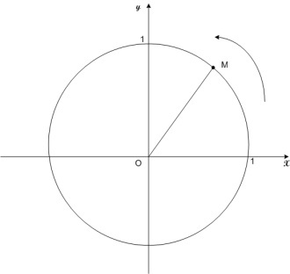 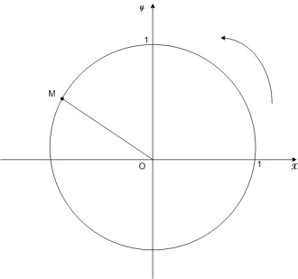 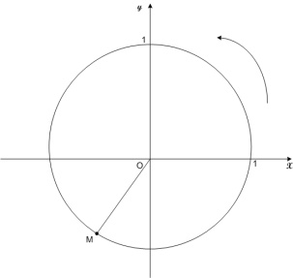 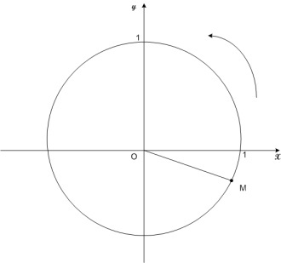

**Tangente**

Pour obtenir une représentation graphique de la tangente de α , on trace la droite t, tangente au cercle trigonométrique au point de coordonnée (1,0).

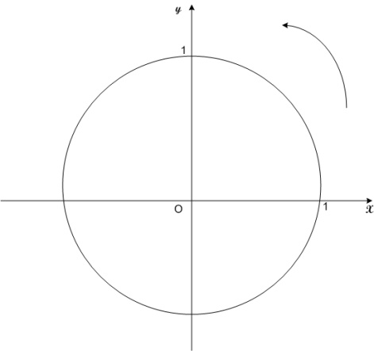

On admet alors que *tan* α (ou *tg* α ) est l’ordonnée du point T d’intersection de t avec l’axe OM.

**Exercice** : Sur chacun des repères, dessine la droite t et indique l’angle α , le point T et le point *tan* α (ou *tg* α ) suivant la position de M.

   

**Cotangente**

Pour obtenir une représentation graphique de la cotangente de α , on trace la droite t’, tangente au cercle trigonométrique au point de coordonnée (0,1).



On admet alors que *cot* α (ou co*tg* α ) est l’abscisse du point T’ d’intersection de t’ avec l’axe OM.

**Exercice** : Sur chacun des repères, dessine la droite t’ et indique l’angle α , le point T’ et le point *cot* α (ou *cotg* α )suivant la position de M.

   

**Signe :**

Voici le signe des nombres trigonométriques d’angles orientés suivant les cadrans :

|  |  |  |  |
| --- | --- | --- | --- |
| cercle | cercle | cercle | cercle |
| SINUS | COSINUS | TANGENTE | COTANGENTE |

1. Propriétés

**Propriété 1 :**

___________________________________________________________________________________________________________________________________________________________________________________________________________________________________________________________________________________________________________________________________________________________________________________________________________________________________________________________________________________________________________________________________________________________________________________________________________________________________________________________________________________________________

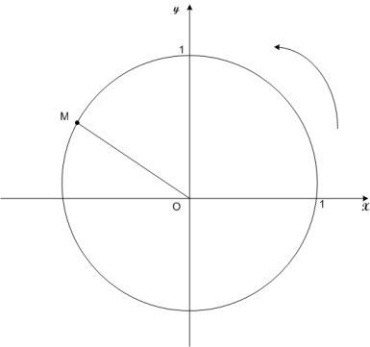 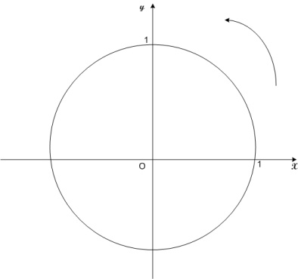 

1. Tableau des valeurs remarquables : **A CONNAITRE**

|  |  |  |  |  |  |
| --- | --- | --- | --- | --- | --- |
| Angle en degré | 0 | 30 | 45 | 60 | 90 |
| Angle en radian | 0 | /6 | /4 | /3 | /2 |
| sin | 0 |  |  |  | 1 |
| cos | 1 | $$\frac{\sqrt{3}}{2}$$ | $$\frac{\sqrt{2}}{2}$$ | $$\frac{\sqrt{1}}{2}= \frac{1}{2}$$ | 0 |
| tan/tg | 0 | $$\frac{1}{\sqrt{3}}= \frac{\sqrt{3}}{3}$$ | 1 | $$\sqrt{3}$$ | $$∄$$ |
| Cot | $$∄$$ | $$\sqrt{3}$$ | 1 | $$\frac{1}{\sqrt{3}}= \frac{\sqrt{3}}{3}$$ | 0 |

**Propriété 2 :**

______________________________________________________________________________________________________________________________________________________________________________________________________________________________________________________________________________________________________________________________________________________________________________________________________________________________________________________________________________________________________________________________________________________________________________________________________________________________________________________________________________________________________________________________________________________________________________

__________________________________________________________________________________________________________________________________________________________________________________________________________________________________________________________________________________________________________________________________________________________________________________________________________________________________________________________________

   

1. Angles associés
2. Vocabulaire et propriétés
3. Les angles  et (π - ) sont appelés _____________________________________

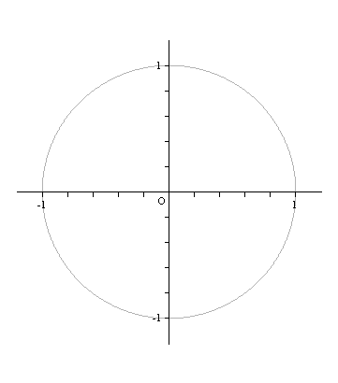 

Caractéristiques de ces angles :

*cos* (π - ) = __________________________________________________

*sin* (π - ) = __________________________________________________

*tan* (π - ) = __________________________________________________

*cotg* (π - ) = __________________________________________________

1. Les angles  et (-) sont appelés _____________________________________

 

Caractéristiques de ces angles :

*cos* (-) = __________________________________________________

*sin* (-) = __________________________________________________

*tan* (-) = __________________________________________________

*cotg* (-) = __________________________________________________

1. Les angles  et (π + ) sont appelés ___________________________________

 

Caractéristiques de ces angles :

*cos* (π + ) = __________________________________________________

*sin* (π + ) = ___________________________________________________

*tan* (π + ) = ___________________________________________________

*cotg* (π + ) = ___________________________________________________

1. Les angles  et ( - ) sont appelés ____________________________________

|  |  |
| --- | --- |
| cercle quart | Caractéristiques de ces angles :  *cos* ( - ) = __________________  *sin* ( - ) = ___________________  *tan* ( - ) = __________________  *cot* ( - ) = __________________ |

Angles et Cercle

RAPPEL de 3ème:

|  |  |
| --- | --- |
| angles&cercle1  angles&cercle2  angles&cercle3 | 1. Toute partie de cercle comprise entre deux points distincts A et B de ce cercle est nommée *arc de cercle*. 2. Deux points distincts A et B d’un cercle déterminent *deux arcs de cercle*. Habituellement, le mathématicien note :   le plus petit des deux arcs par  (lu « arc AB »);  le plus grand des deux, au moyen d’un point intermédiaires, ici  (lu « arc ASB »). 3. Le segment de droite qui joint deux points d’un cercle porte le nom de *corde du cercle* ou plus brièvement de *corde*. [AB] est une corde. 4. Une corde du cercle sous-tend les deux arcs de cercle qui ont comme extrémités celles de la corde. [AB] sous-tend  et . 5. Tout angle dont le sommet est le centre d’un cercle est appelé *angle au centre* de ce cercle. Tout angle dont le sommet appartient à un cercle et dont les côtés coupent ce cercle est appelé *angle inscrit* à ce cercle.  est un angle au centre du cercle ;  est un angle inscrit au cercle. 6. Un angle au centre d’un cercle ou un angle inscrit à ce cercle intercepte la corde dont les extrémités sont les points d’intersection du cercle avec les côtés de l’angle.  intercepte la corde [AB] ;  intercepte la corde [CE]. |