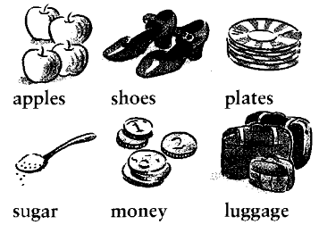
Countable and uncountable words
Que peut-on compter?
Countable (tu peux les compter: 4 apples, 2 shoes)
Uncountable (tu ne peux pas les compter !)
On ne dit pas 3 luggages.

Vocabulaire « uncountable » courant
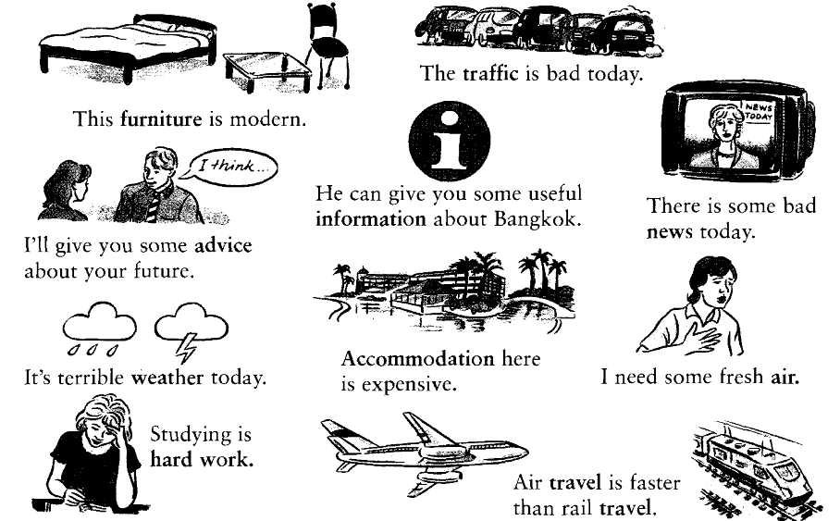

La nourriture
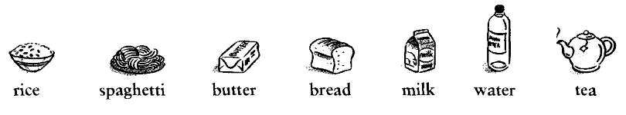
Beaucoup de mots « uncountable » concernent la nourriture et les boissons

Quand tu veux dire la quantité que tu désires, tu dis, three loaves of bread, two litres of milk, a kilo of apples.
Exercices

Complète les phrases suivantes avec un uncountable.
- I’d like to buy a car but I haven’t got enough …………………………… .
- Cows give us ……………………….. and ………………………….
- If you don’t know what to do, ask your parents for some ………………………… .
- The ………………………… at the seaside is very good for you.
- Rob left school last month and is now looking for ………………………. .
- There is always a lot of …………………… in central London.

Relie les mots des 2 colonnes entre eux.
- Heavy information
- Useful travel
- Bad water
- Modern luggage
- Brown news
- Cold furniture
- Space bread

Trouve un adjectif qui complète les noms uncountable de la liste suivante
Cold weather, British money
Weather money sugar traffic advice accommodation air
Work rice spaghetti butter milk tea coffee
………………………………………………………………………………………………………………………………………………………………………………………………………………………………………………………………………………………………………………………………………………………………………………………………………………………………………………………………………………………………………………………………………………………………………………………………………………………………………………………………………………………………………………………………………………………………………………………………………………………………
Complète les phrases avec la forme correcte de be.
- Accommodation in the city centre ………… expensive.
- Spaghetti with Italian tomato sauce ……… very good.
- The weather in Scotland ……. best in the autumn.
- The news ……. Better today than it …… yesterday.
- Work …… the most important thing in Sam’s life.
- Their furniture ……. very old and very beautiful.

Corrige les fautes dans les phrases suivantes.
- The news are not very good today. The news is not very good today.
- Where can I get some informations about your country? ………………………………………………………………………………………………………………………
- Let me give you an advice. ………………………………………………………………………………………………………………………
- Cook these spaghetti for ten minutes. ………………………………………………………………………………………………………………………
- Can I have a bread, please? ………………………………………………………………………………………………………………………
- Mary is looking for a new work. ………………………………………………………………………………………………………………………
- We should buy some new furnitures. ………………………………………………………………………………………………………………………
- The east of the country usually has a better weather than the west. ………………………………………………………………………………………………………………………
- We went on two long travels last year. ………………………………………………………………………………………………………………………
- I must find a new accommodation soon. ………………………………………………………………………………………………………………………

Keys
Complète les phrases suivantes avec un uncountable.
1 money 3 advice 5 work
2 milk ;butter 4 air 6 traffic
Relie les mots des 2 colonnes entre eux.
1 heavy luggage 5 brown bread
2 useful information 6 cold water
3 bad news 7 space travel
4 modern furniture
Trouve un adjectif qui complète les noms uncountable de la liste suivante
Brown sugar ; heavy traffic ; good advice ; expensive accomodation ; fresh air ; hard work; brown rice; delicious spaghetti; unsalted butter; cold milk; Indian tea; Colombian coffee
Complète les phrases avec la forme correcte de be.
1 is/was 3 is/was 5 is/was
2 is/was 4 is ;was 6 is/was
Corrige les fautes dans les phrases suivantes.
2. Where can I get some information about your country?
3. Let me give some advice.
4. Cook this spaghetti for ten minutes.
5. Can I have some bread, please?
6. Mary is looking for a new job.
7. We should buy some new furniture.
8. The east of the country usually has better weather than the west.
9. We went on two long journeys last year.
10. I must find some new accommodation soon.

