The weather ? It’s so important
- Vocabulary

3.1. Match the expression to the right picture.
A. It's sunny | B. It's snowing | C. It's raining/rainy
D. It's foggy | E. It's hot | F. It's cold
G. It's cloudy | H. It's windy | I. It's freezing
J. It’s stormy | K. it’s dry | L.it’s wet

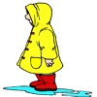
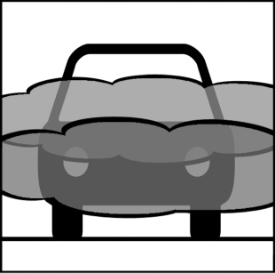
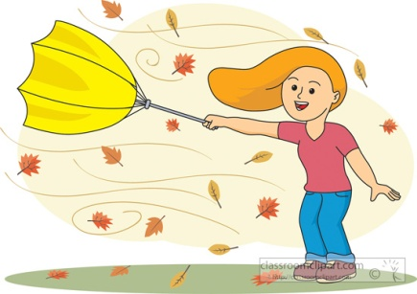
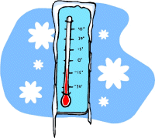

1 2 3 4

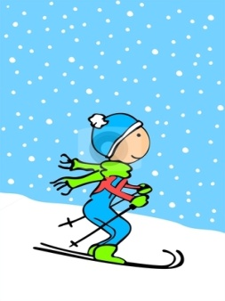
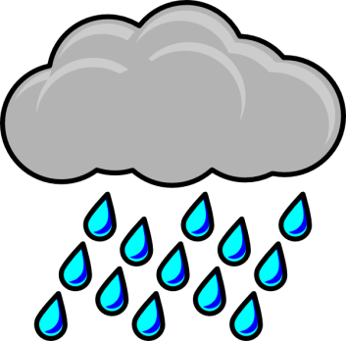
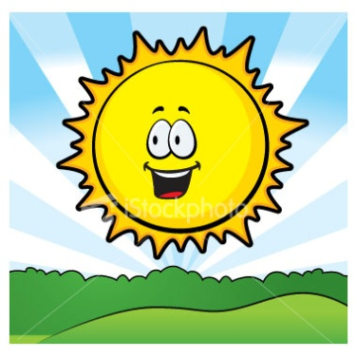

5 6 7 8
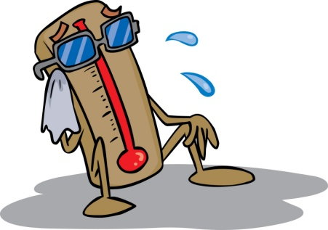
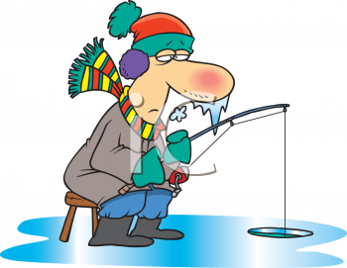
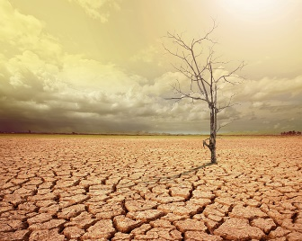
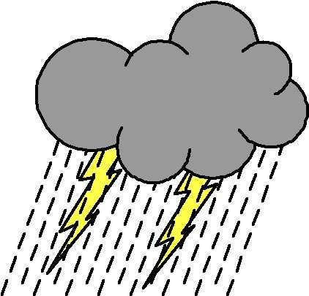

9 10 11 12

A | B | C | D | E | F | G | H | I | J | K | L

3.2. Find the word that belongs to the expression

____________ → It's sunny
____________ → It's cloudy
____________ → It's snowy
____________ → It's rainy
____________ → It's windy
____________ → It's foggy

Conclusion : ___________________ __________________

3.3 . Match each season with its corresponding definition
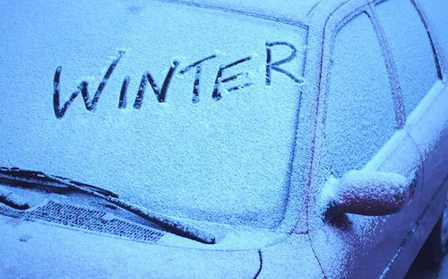
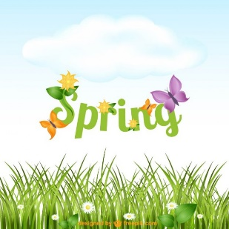
The days are very short and it is generally cold and often wet, sometimes it snows. We celebrate Christmas .

- See more at: http://www.learnenglish.de/basics/seasons.html#sthash.8Y2K5qRZ.dpuf
The days are long, the weather is warm. The first flowers appear.it often rains and can get very windy. We celebrate Easter

- See more at: http://www.learnenglish.de/basics/seasons.html#sthash.8Y2K5qRZ.dpuf
The days are short, it gets cold and rainy and the leaves fall from the trees. We celebrate Halloween.

- See more at: http://www.learnenglish.de/basics/seasons.html#sthash.8Y2K5qRZ.dpuf
The days are very long and the weather is usually warm and sometimes even hot. We usually go on holiday during this season.

- See more at: http://www.learnenglish.de/basics/seasons.html#sthash.8Y2K5qRZ.dpuf

Rainbow | Raindrops | Wind | Thunderstorm | Foggy | Snow
3.4 : Fill in the sentence with the right word

- The leaves of the tree are falling because there is some ……………………

- I see a ……………….. after it is raining all day . it’s an arc of colors in the sky. It’s beautiful

- When there is ………………… , you can see lightning in the sky and it's very noisy. Don’t stay outside

- There is --------------------------- on the mountains during the winter

- There are thousands of ……………….. when its raining

- I don't see very well because it’s …………………….

- Writing – Speaking

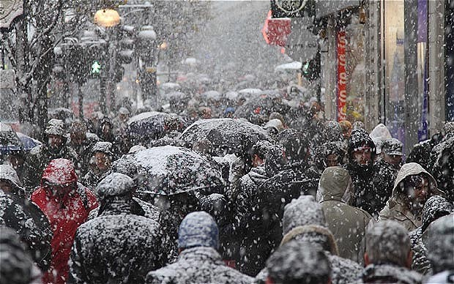
- Describe the weather and what you see in each picture
--------------------------------------------------------------------
--------------------------------------------------------------------
--------------------------------------------------------------------
--------------------------------------------------------------------
--------------------------------------------------------------------
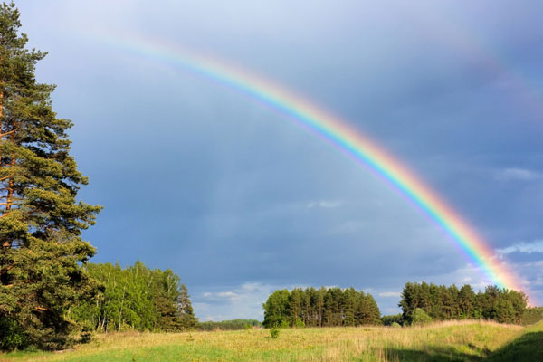
--------------------------------------------------------------------
--------------------------------------------------------------------
--------------------------------------------------------------------
-------------------------------------------------------------------

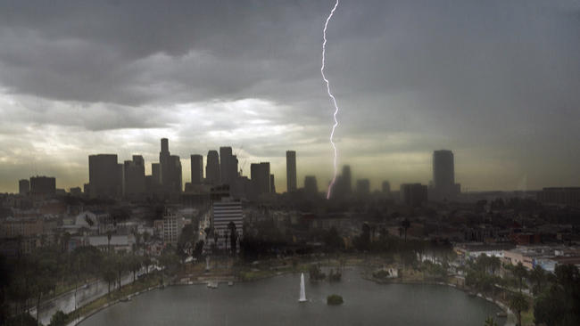
- Speak with your partner about the weather and what you see in each picture

