EVEN AND ODD NUMBERS

- Even number = ...........................................................................................
- The last number is:.......................................................................
- Odd number = ...........................................................................................
- The last number is:.........................................................................

Give me 5 odd numbers : ...................................................................................
Give me 5 even numbers : .................................................................................
Here is a number grid, color in green the even numbers.
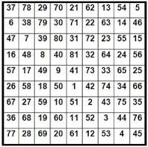
Find the intruder in each line.
18 - 77 - 484 - 62 - 6 - 200 - 986 the intruder is .......................
650 - 363 - 877 - 55 - 971 - 495 the intruder is .......................
284 - 1286 - 3527 - 622 - 346 - 78 the intruder is .......................
129 - 879 - 537 - 777 - 444 - 8753 the intruder is .......................

Forming odd/even numbers.
Write the greatest odd number formed by the digits 2, 8 and 5.
........................................................................................................................
Write the smallest even number formed by the digits 4, 3, 1 and 6.
........................................................................................................................
Write the smallest odd number formed by the digits 7, 2 and 9.
........................................................................................................................
Write the greatest even number formed by the digits 5, 7, 6 and 1.
........................................................................................................................
Write all possible odd numbers formed by the digits 3, 6 and 2.
........................................................................................................................
Write all possible even numbers formed by the digits 6, 1 and 8.
........................................................................................................................
Write all possible odd numbers formed by the digits 7, 4 and 9.
........................................................................................................................

Coloring odd/even numbers.
Odd numbers = purple Even numbers = orange
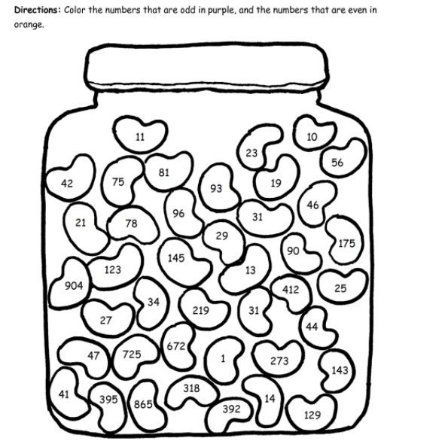

Addition and soustraction of odd/even numbers. Find the result.

27+32=________ 97-56=_________
123-27=_______ 44+15=_________
175+25=_______ 78-26=_________
26+436=_______ 89+21=_________
136-54=________ 201+99=________
108-12=________ 286+44=________
244-62=________ 67+98=_________

356+232=_______ 17-9=_________
193-78=________ 45+57=________

