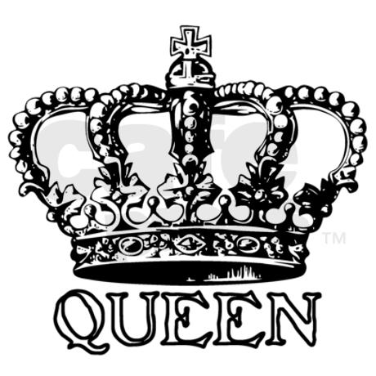
Name:

The British Royal Family

The British royal family are undoubtedly one of the most famous in the world. Officially, 'the royal family' is comprised of the ruling monarch and the consort (husband or wife), their children, grandchildren and great grandchildren.
Queen Elizabeth II has ruled as Head of State since 1953, amassing a huge 64 years. Prince Charles is the heir apparent, and will eventually succeed the Queen. Prince William is second in line, whilst his son Prince George is third.
Queen Elizabeth II is a constitutional monarch. She does not really govern her country (the United Kingdom is run by the Prime Minister and the government). But she does many important things for her country : she invites other world leaders to come to the United Kingdom. As head of the Armed Forces, she is the only one who can declare war on another country. Every day the Queen receives a lot of documents that she must read and sign. Finally, she visits a lot of different places such as hospitals, schools, etc... all around the United Kingdom.
Take a look at our ultimate fact file, to find out everything you've ever wanted to know...

List of British monarchs
Our current monarch, Queen Elizabeth II, is the longest reigning monarch ever. But who preceded her?
Edward VII began the Queen's royal house, reigning from 1901 - 1910.
George V came after that, ruling for 26 years, from 1910 - 1936, and was succeeded by Edward VIII.
However, Edward VIII abdicated soon after coming onto the throne (only 10 months and 21 days), leaving his brother to take up the responsibility, George VI.
The Queen's father reigned until his death in 1952, when Elizabeth II took up the role and became the ruling monarch.

Royal family names
Prior to 1917, members of the British royal family didn't have a proper surname. Instead, They simply belonged to the House of Saxe-Coburg-Gotha.
But the royal family change later their surname to Windsor, to give the British royal family a more English-sounding last name.
However, since 1960, Prince Philip and the Queen were granted permission to give their direct descendants the name Montbatten-Windsor, combining his and her surnames.
The Queen's full name at birth was Elizabeth Alaxandra Mary although she was often referred to as Lilbet by loved ones, when she was young.
Unlike his mother, Prince Charles (or the Prince of Wales), resides in just one official crown estate, Clarence House in London. However, the Prince and Duchess of Cornwall have just one private residence, Birkhall in Balmoral, near to the Queen's favourite private residence.

Clarence house

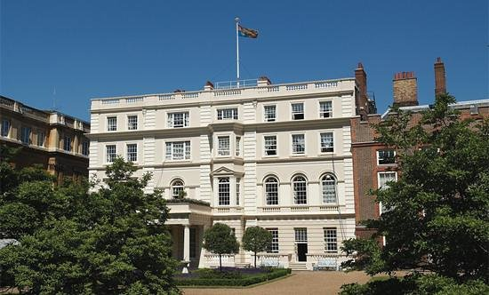
The Duke and Duchess of Cambridge, william and Kate, have just two residences at their disposal - Kensington Palace and Anmer Hall in Norfolk.
And Prince Harry has just one royal residence, Kensington Palace, where he's installed at the modestly sized Nottingham Cottage.

Kensington Palace
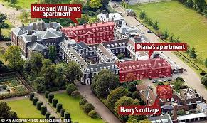

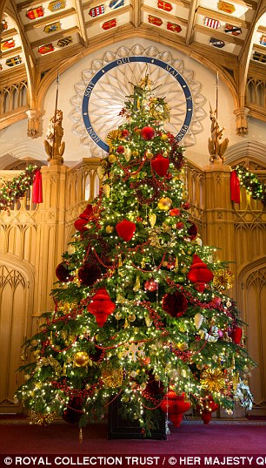
Where do the royal family spend Christmas?
Generally, the entire royal clan will spend Christmas at the Sandringham estate, which is big enough to house the whole lot of them. The Queen and Prince Philip will usually go there first, by train, with the rest of the family following afterwards, normally arriving on Christmas Eve. Then the family as a whole go to Church in Sandringham, and always have a traditional dinner together.

What traditions do the royal family have?
One tradition is based around a security fear. In the protocol, it's not allow for family members of the same line to travel in the same airplane together.
But Prince William became one of the first to break the rules, when he travelled to Canada in the same plane as son Prince George, who is primed to succeed him one day.

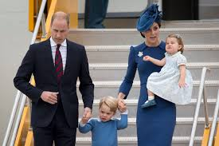

William and Kate arrive in Canada with their childrens

Another pretty intense tradition is the fact that the royal household will take a hostage every time the Queen attends the State Opening of Parliament. Yes, you heard that right - a hostage.
The strange rule harks back to the long time. And the tradition is amazingly still upheld to this day, but don't worry. The chosen MP is always well-looked after.

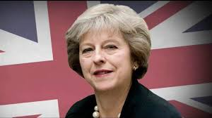

Theresa May
Prime minister

And finally, the royal family have a Christmas tradition that's so normal, you might well do it yourself come the festive season.
The family exchange cheap and funny presents amongst each other - with the tackiest winning the prize. Apparently, Prince William once famously gifted his grandmother a bath hat with 'Queen of the year' written on it.
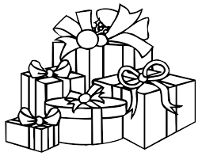

Some vocabulary.
Undoubtely = sans aucun doute
One of the most famous = une des plus célèbres
Ruling = règnant. (mais c'est aussi : décision, verdict)
To rule = régner
Amassing = accumuler
Huge = énorme
Heir apparent = successeur potentiel.
Whilst = alors que
Constitutional monarch= souverain constitutionnel = est à la tête du pays mais n'a pas de pouvoir décisionel.
To run = diriger (et évidemment cela veut dire "courir")
She does = cela vient du verbe to do (faire) = elle fait
Many things = beaucoup de choses.
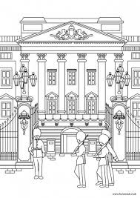
Country = pays
The only one = la seule
She must = elle doit (to must)
A lot of = beaucoup de
All around = partout
Take a look = jetons un coup d'œil
Fact file = dossier de "faits"
To find out = découvrir
Ever wanted to know = toujours cherché à savoir
Current = actuel (courant)
Ever = jamais, toujours
Began = forme passée de To begin = commencer
Came = forme passée de to come = arriver, venir
However = pourtant, cependant
Soon = tôt
Onto = sur
Leaving = laissant (du verbe to leave = quitter, laisser)
Until = jusqu'à
Took up = forme passée du verbe to take = prendre
Prior to = avant, au préalable
Proper surname = nom de famille approprié
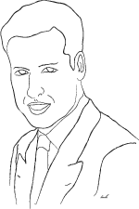
Instead = au lieu de cela
To belong = appartenir
Later = plus tard
More = plus
Were granted permission = ont été autorisés
Although = bien que
Often = souvent
Trooping the colour = le salut au drapeau
Crowned = couronné
To attend= assister à
Is fond of = adorer
It means = ça veut dire
To spend some time = passer du temps
Unlike = contrairement à
Crown estate = pas de traduction, c'est un organisme officile anglais.
Near = proche, près
Entire = entier, complèt
Estate = domaine, propriété
The whole = entier, tou, complet, l'ensemble
The whole lot = tous (sans exception)
To house = loger, héberger the house = la maison
Usually = d'habitude
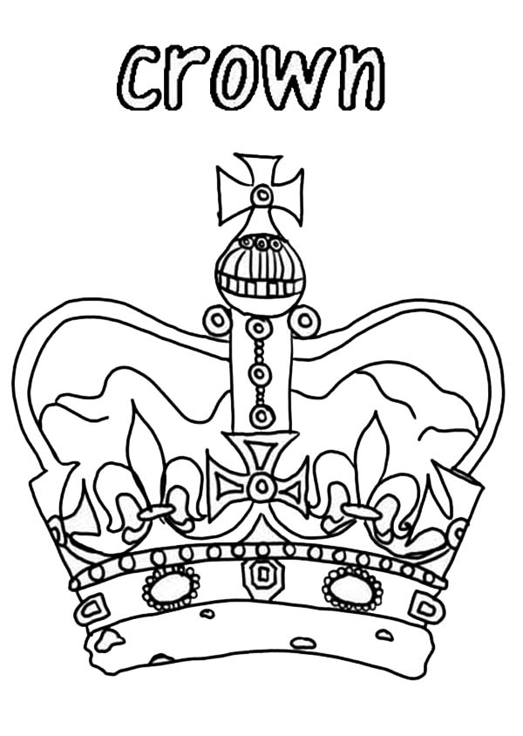
Afterwards = après, par la suite
Christmas eve = la veille de Noël
Is based = repose
Around = autour
Fear = crainte
One of the first = un des premiers
To travel = voyager
The same = le même
Plane = avion
Who is primed = qui est prêt
Pretty intense = assez intence
Royal household = la maison royale
Yes, you heard that right: oui, vous avez bien entendu
Strange = étrange
To hark back to = remonter à
Amazingly = incroyablement
Still = encore
Upheld = vient de uphold = maintenu
Don't worry = ne vous inquiétez pas
Always = toujours
You might well = vous pourriez bien
To exchange = échanger
Cheap = bon marché
Funny = amusant, drôle
Amongst each other = entre eux
The tackiest = le pire
Winning = to win = gagner

If you have another words you don't understand...

Family vocabulary.
Try to translate the vocabulary about family. Work with you pencil.

Maman =
Papa =
Parents =
Grand-mère =
Grand-père =
Grands-parents =
Frère =
Sœur =
Fils =
Fille =
Enfant(s) =
Fratrie =
Petit-fils =
Petite-fille =
Petits-enfants =
Arrière petits-enfants =
Oncle =
Tante =
Cousin =
Cousine =
Neveu =
Nièce =
Beau-père =
Belle-mère =

The royal family quizz.

What it the surname of the Royal Family?
a) Buckingham
b) Windsor
c) Kensington

Which member of the Royal Family is next in line to the throne?
a) Prince Charles
b) Prince William
c) Prince Andrew

What’s the name of the Queen’s official residence in London?
a) The Tower of London
b) Buckingham Palace
c) Westminster House

Which member of the Royal Family died on 31st August 1997?
a) Lady Diana
b) The Queen Mother
c) Princess Margaret

What is Prince Charles’ wife’s official title?
a) Princess of Cornwall
b) Queen of Cornwall
c) Duchess of Cornwall

Which member of the Royal Family was born on 2nd May 2015?
a) Princess Eugenie
b) Princess Charlotte
c) Prince George

When did Elizabeth II become Queen of England?
a) 1962
b) 1972
c) 1952

The Queen is the Head of ...
a) State
b) Nation
c) the Armed Forces

The Royal family is the symbol of ...
a) the country, its traditions and history
b) right political regime
c) national identity, unity and pride

How much members of the royal family are born in the 20th century? .................................................................................

