Name: GEOGRAPHY

HOW TO USE AN ATLAS ?
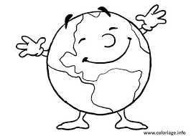

An atlas is a type of reference book that contains maps and other geographical information.

Find a specific map in an atlas using the table of contents or index page

I take an example i would like to find the map of the "GRANDE BRETAGNE" (Great Britain in english )

- You find, in first, the name of the country / city in the alphabetical list. Usualy, the index is in the end of the atlas.

- Example : if you look for "GRANDE BRETAGNE"
- You go to the letter "G" ine the alphabetical list.
- "GRANDE BRETAGNE" is in the second row (column).

- After, backside of the name, you have a number, it's the page number where you will find the map

- Example : "GRANDE BRETAGNE" 7
- You find the map in page 7

!! If you have an * after the name = it's a country or a state !!
- The map's key (la légende de la carte)

The map's key show what the map's colors and signs means.

Population

The number of people living in cities (villles) and municipalities (communes)

Now that you understand this well, you can make an exercice.

Try to find the following countries, cities in the atlas.
Write the number of the page next to the name

- Belgique (Belgium) : ...........................
- Amazonie (Amazonia) : ......................
- Bruxelles (Brussels) : ........................
- Châtelet : .............................
- Egypte (Egypt) : ....................
- Katar (Qatar) : ...................
- Pôle Nord (North Pole) : ......................
- New - York : ......................
- Océan Atlantique (Atlantic Ocean) : ........................
- Tokio (Tokyo) : ...........................

