Les systèmes du corps humain : évaluation

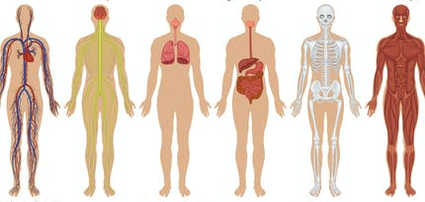

- Pour chaque dessin, complète les différentes colonnes du tableau.

N° | Nom du système | A quoi il sert | Organe principal
1 | __________________  __________________ | __________________________  __________________________  __________________________ | _______________
2 | __________________  __________________ | __________________________  __________________________  __________________________ | _______________
3 | __________________  __________________ | __________________________  __________________________  __________________________ | _______________
4 | __________________  __________________ | __________________________  __________________________  __________________________ | _______________
5 | __________________  __________________ | __________________________  __________________________  __________________________ | _______________
6 | __________________  __________________ | __________________________  __________________________  __________________________ | _______________

- Pour chaque système, trouve une maladie, un problème, un accident … qui pourrait l’affecter.
- ___________________________________________________________________________________________________________________________________________________________________________________________________
- ___________________________________________________________________________________________________________________________________________________________________________________________________
- ___________________________________________________________________________________________________________________________________________________________________________________________________
- ___________________________________________________________________________________________________________________________________________________________________________________________________
- ___________________________________________________________________________________________________________________________________________________________________________________________________
- ___________________________________________________________________________________________________________________________________________________________________________________________________

