THE SIMPLE PAST / PRÉTÉRIT
3e TQ — English Course Pack
Theme: Holidays, Trips & Memories
1. OBJECTIFS DU CHAPITRE
À la fin du module, l’élève sera capable de :
- parler d’événements passés ;
- raconter des vacances ;
- poser des questions au passé ;
- comprendre un récit simple au prétérit ;
- utiliser les verbes réguliers et les verbes irréguliers fréquents ;
- écrire un petit récit personnel ;
- comprendre la différence entre présent et passé.
2. QU’EST-CE QUE LE PRÉTÉRIT ?
Le prétérit (= Simple Past) sert à parler :
- d’une action TERMINÉE dans le passé ;
- d’un événement daté ;
- d’une habitude passée ;
- d’une suite d’actions dans une histoire.

3. LES MOTS INDICES DU PASSÉ

English | Français
yesterday | hier
last week | la semaine passée
last summer | l’été dernier
two days ago | il y a deux jours
in 2024 | en 2024
when I was young | quand j’étais jeune
during the holidays | pendant les vacances

4. FORMATION DU PRÉTÉRIT
Les verbes réguliers
On ajoute -ED au verbe.
Base Verb | Simple Past
play | played
visit | visited
watch | watched
clean | cleaned
travel | travelled

Prononciation du -ED :

Verbe | Prononciation | Son
watched | /wɒtʃt/ | “wotcht”
played | /pleɪd/ | “plèyd”
visited | /ˈvɪzɪtɪd/ | “vi-zi-tid”

5. LES VERBES IRRÉGULIERS
Ils changent complètement.
Base Verb | Past Simple | Français
go | went | aller
have | had | avoir
eat | ate | manger
see | saw | voir
come | came | venir
👉 Il faut les apprendre progressivement.
6. STRUCTURE DES PHRASES
A. Phrase affirmative
Sujet + verbe au prétérit

Exemples :
- I visited Spain last summer.
- We stayed in a hotel during the holidays last week.
- Yesterday, they ate pizza on the beach.
B. Phrase négative
Sujet + did not (didn’t) + base verb
⚠️ Le verbe redevient NORMAL.

Exemples :
- I didn’t go to school.
- She didn’t eat fish.
- We didn’t travel by plane.
C. Questions
Did + sujet + base verb ?

Exemples :
- Did you enjoy your holidays?
- Did they visit London?
- Did she swim in the sea?
D. Réponses courtes

Question | Réponse
Did you travel? | Yes, I did.
Did he cook? | No, he didn’t.

7. LE VERBE “TO BE” AU PASSÉ
Present | Past
am/is | was
are | were

Exemples :
- I was tired.
- They were happy.
- The hotel was beautiful.
8. PETITES HISTOIRES
“A TERRIBLE HOLIDAY”

Last summer, Tom and his friends travelled to Spain.
They stayed in a small hotel near the beach.
On the first day, they swam in the sea and ate delicious food.
Everything was perfect.
But on the second day, Tom lost his wallet.
He looked everywhere but he didn’t find it.
Later, they visited a water park.
Tom fell into the water with his phone in his pocket.
His friends laughed a lot.
At the end of the holiday, Tom said:
“Next year, I’m going to stay home!”

Questions de compréhension
- Where did Tom go?
- Did he stay in a hotel?
- What did he lose?
- Did he find his wallet?
- Why did his friends laugh?

9. ARTICLE SIMPLE
“Belgians Love Travelling”
Every year, many Belgian families travelled abroad during the summer holidays.
Last year, Spain, France and Italy were very popular destinations.
Some tourists travelled by plane, but others preferred the car because it was cheaper.
Many people visited museums, walked in old cities and relaxed on the beach.
Unfortunately, some tourists experienced problems:
- delayed flights,
- bad weather,
- lost luggage,
- expensive restaurants.
Despite these problems, most tourists enjoyed their holidays.
10. VOCABULAIRE DES VACANCES
English | Français
beach | plage
hotel | hôtel
suitcase | valise
passport | passeport
train station | gare
flight | vol
luggage | bagages
campsite | camping
map | carte
tourist | touriste
towel | serviette
sea | mer
mountain | montagne
journey | voyage
trip | excursion

11. LES 42 VERBES IRRÉGULIERS LES PLUS UTILISÉS
1. Les 3 formes IDENTIQUES
Verbe | Simple Past | Present Perfect | Français | Mini-phrase
cut | cut | cut | couper | I cut the paper yesterday.
hit | hit | hit | frapper | He hit the ball this morning.
hurt | hurt | hurt | blesser | My leg hurt last night.
let | let | let | laisser | She let me enter yesterday.
put | put | put | mettre | I put the book here earlier.
set | set | set | placer | He set the table yesterday evening.
shut | shut | shut | fermer | She shut the door suddenly yesterday.
cost | cost | cost | coûter | The phone cost 200€ last year and now it costs 210€.

2. Famille en -ought / -aught
Base verbale | Simple Past | Present Perfect | Français | Mini-phrase
bring | brought | brought | apporter | I brought my bag yesterday.
buy | bought | bought | acheter | She bought a dress last week.
think | thought | thought | penser | We thought about you yesterday.
catch | caught | caught | attraper | He caught the bus this morning.
teach | taught | taught | enseigner | The teacher taught English last year.
3. Famille en -ew / -own

Base verbale | Simple Past | Present Perfect | Français | Mini-phrase
blow | blew | blown | souffler | The wind blew strongly yesterday.
know | knew | known | savoir / connaître | I knew the answer immediately yesterday.
grow | grew | grown | pousser / grandir | The plant grew quickly last summer.
throw | threw | thrown | lancer | He threw the ball yesterday afternoon.
fly | flew | flown | voler | The bird flew away earlier.
4. Famille en -oke / -oken

Base verbale | Simple Past | Present Perfect | Français | Mini-phrase
break | broke | broken | casser | She broke the glass yesterday.
speak | spoke | spoken | parler | They spoke English all day yesterday.
wake | woke | woken | réveiller | I woke up very early this morning.

5. Famille en -ang / -ung

Base verbale | Simple Past | Present Perfect | Français | Mini-phrase
sing | sang | sung | chanter | She sang beautifully last night.
drink | drank | drunk | boire | We drank water after lunch.
ring | rang | rung | sonner | The bell rang suddenly this morning.
swim | swam | swum | nager | He swam in the sea yesterday.
begin | began | begun | commencer | The lesson began late yesterday.

6. Participes en -en

Base verbale | Simple Past | Present Perfect | Français | Mini-phrase
write | wrote | written | écrire | I wrote a letter yesterday evening.
drive | drove | driven | conduire | She drove to school this morning.
ride | rode | ridden | rouler / monter | He rode a bike last Sunday.
choose | chose | chosen | choisir | We chose pizza yesterday.
eat | ate | eaten | manger | They ate quickly after class.

7. Les verbes irréguliers et indispensables

Base verbale | Simple Past | Present Perfect | Français | Mini-phrase
be | was/were | been | être | I was tired yesterday.
do | did | done | faire | She did her homework last night.
go | went | gone | aller | We went to Brussels last weekend.
have | had | had | avoir | He had a dog years ago.
make | made | made | faire / fabriquer | I made a cake yesterday afternoon.
say | said | said | dire | She said hello this morning.
see | saw | seen | voir | We saw a movie last Friday.
take | took | taken | prendre | He took the train yesterday.
come | came | come | venir | They came late yesterday evening.
get | got | got | obtenir | I got a gift last Christmas.
give | gave | given | donner | She gave me water earlier.

12. LES RÈGLES D’ÉCRITURE DU PRÉTÉRIT
A. Règle générale
On ajoute généralement -ED au verbe.
Base Verb | Past Simple
play | played
visit | visited
clean | cleaned

B. Les verbes qui se terminent par -E
On ajoute seulement -D.
Base Verb | Past Simple
live | lived
dance | danced
love | loved
change | changed
C. Les verbes qui se terminent par -Y
1. Consonne + Y → Y devient I + ED
Base Verb | Past Simple
study | studied
carry | carried
try | tried

2. Voyelle + Y → on garde le Y
Base Verb | Past Simple
play | played
enjoy | enjoyed
stay | stayed

D. Les verbes CVC
Les verbes qui se terminent par un CVC = consonne + voyelle + consonne, on double la dernière consonne avant d’ajouter -ED, parce que la voyelle est courte.
Base Verb | Structure | Past Simple
stop | CVC | stopped
plan | CVC | planned
shop | CVC | shopped

E. Les verbes CVVC
Les verbes qui se terminent par un CVVC = consonne + voyelle + voyelle + consonne, on ne double généralement pas, parce que :
- les deux voyelles produisent souvent un son long ;
- il n’y a donc pas besoin de doubler la consonne.
Base Verb | Structure | Past Simple
look | CVVC | looked
clean | CVVC | cleaned
rain | CVVC | rained

C. Attention : ce n’est pas la seule règle
Le doublement dépend aussi :
- de l’accent tonique ;
- de la longueur du mot.
Base Verb | Past Simple
open | opened
visit | visited
prefer | preferred
Pourquoi “preferred” double ?
Pre-FER : accent sur la dernière syllabe.

Pourquoi “opened” ne double pas ?
O-pen : accent sur la première syllabe.

13.EXERCICES
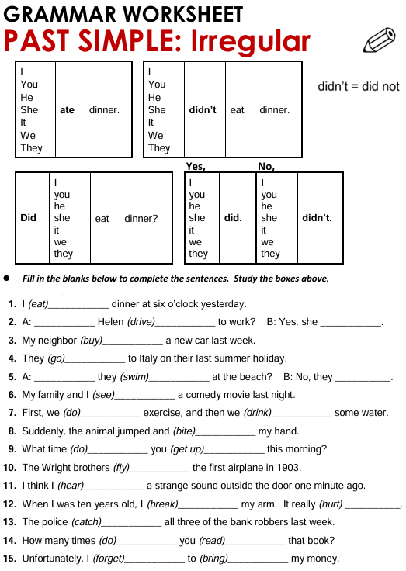
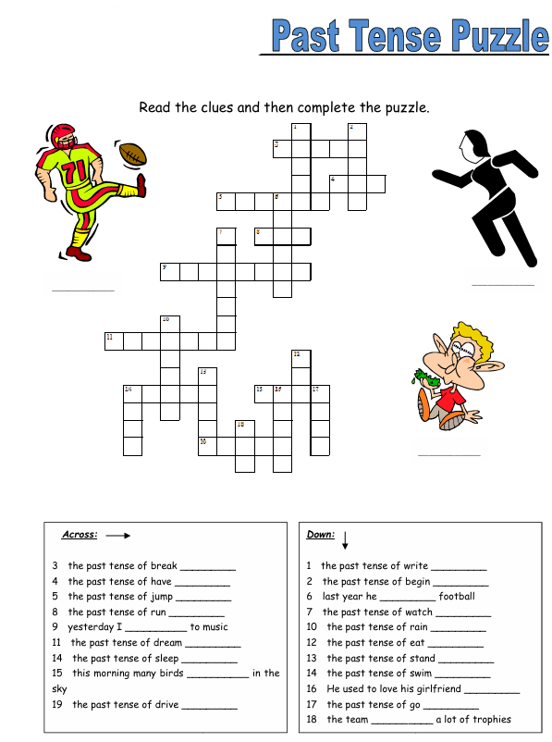
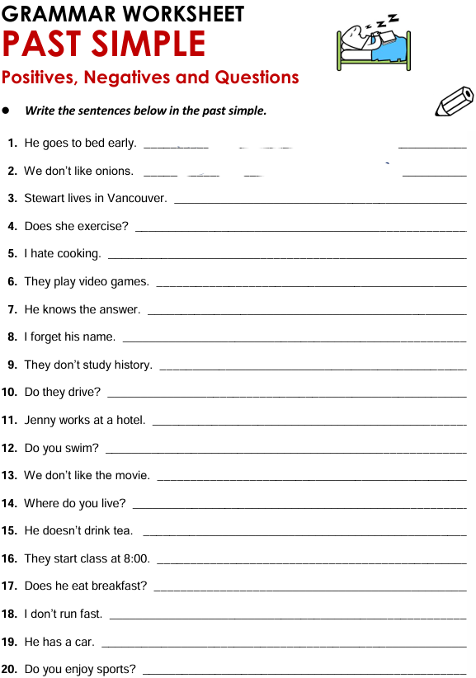
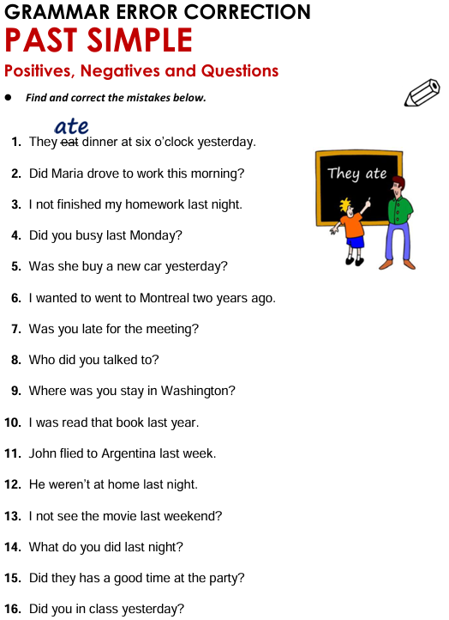
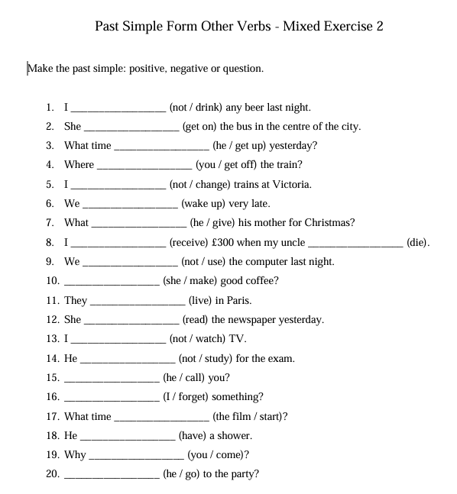

Holidays & Unexpected Problems

TEXT

(to rent = louer / to hike = se promener / however = cependant / backpack = sac à dos / fortunately = heureusement
Last August, Sarah and her friends travelled to Scotland for their summer holidays.
They rented a small house near a lake and stayed there for ten days.
During the first week, the weather was wonderful.
They hiked in the mountains, visited old castles and took hundreds of photos.
However, things changed after a few days.
One evening, Sarah realised that she didn’t have her backpack anymore.
She looked for it everywhere, but she couldn’t find it.
Fortunately, a local farmer found the bag near a bus stop and brought it back the next morning.
At the end of the holiday, Sarah said it was the best trip of her life despite the problem.

A. ANSWER THE QUESTIONS
- Where did Sarah go during her holidays?

- How long did they stay there?

- What activities did they do during the first week?

- What problem did Sarah have?

- Who found the backpack?

B. TRUE OR FALSE? JUSTIFY WITH THE TEXT
- Sarah travelled alone.
TRUE / FALSE
Justification : ________________________________________
- The weather was bad during the whole holiday.
TRUE / FALSE
Justification : ________________________________________
- Sarah lost her backpack in the mountains.
TRUE / FALSE
Justification : ________________________________________
- A farmer helped Sarah.
TRUE / FALSE
Justification : ________________________________________
- Sarah hated her holiday.
TRUE / FALSE
Justification : ________________________________________
C. CORRECT THE MISTAKES
⚠️ Each sentence contains ONE mistake.
- Sarah and her friends was in Scotland.

- They taked many photos during the trip.

- Sarah didn’t found her backpack.

- Did the farmer brought the bag back?

- They hiked in the mountain every day.

D. FIND IN THE TEXT
Find:
- one regular verb in the simple past : __________________
- one irregular verb in the simple past : __________________
- one negative sentence : _______________________________
- one time expression : _________________________________
- one verb with CVC double consonant : __________________

Les connecteurs pour bien s’exprimer
1. Les connecteurs de temps
Connecteur | Français | Exemple
first | d’abord | First, I took a shower.
then | ensuite | Then, I went to school.
after that | après cela | After that, I did my homework.
later | plus tard | Later, I watched TV.
finally | finalement | Finally, I went to bed.
yesterday | hier | Yesterday, I stayed home.
last week | la semaine passée | Last week, we visited London.
this morning | ce matin | This morning, I was tired.

2. Les connecteurs d’addition
Connecteur | Français | Exemple
and | et | I like football and basketball.
also | aussi | She also speaks Dutch.
too | aussi | I like pizza too.
moreover | de plus | He is intelligent, moreover, he is kind.
in addition | en plus | In addition, the exercise was easy.

3. Les connecteurs d’opposition
Connecteur | Français | Exemple
but | mais | I was tired, but I finished.
however | cependant | However, the test was difficult.
although | bien que | Although he was sick, he came.
on the other hand | d’un autre côté | On the other hand, it was expensive.
4. Les connecteurs de cause
Connecteur | Français | Exemple
because | parce que | I stayed home because I was sick.
since | puisque | Since it was raining, we stayed inside.
as | comme | As I was tired, I went to bed.

5. Les connecteurs de conséquence
Connecteur | Français | Exemple
so | donc | It was late, so we left.
therefore | par conséquent | He studied, therefore, he passed.
that’s why | c’est pourquoi | I was sick, that’s why I stayed home.

6. Les connecteurs d’exemple
Connecteur | Français | Exemple
for example | par exemple | I like sports, for example football.
for instance | par exemple | Some animals, for instance cats, sleep a lot.

7. Les connecteurs d’opinion
Connecteur | Français | Exemple
I think | je pense | I think English is important.
in my opinion | à mon avis | In my opinion, school is useful.
personally | personnellement | Personally, I prefer summer.

Tableau résumé ultra simple
Fonction | Connecteurs utiles
Ajouter une idée | and, also, too
Opposer une idée | but, however
Expliquer une cause | because, since
Donner une conséquence | so, therefore
Organiser un récit | first, then, finally
Donner son opinion | I think, personally
Donner un exemple | for example

14. MINI PROJET FINAL
“My Worst Holiday Ever”
Les élèves doivent écrire :
- où ils sont allés ;
- ce qu’ils ont fait ;
- un problème ;
- une anecdote drôle ;
- une conclusion.
Minimum :
- 80 mots ;
- 10 verbes au prétérit (simple past) ;
- 10 connecteurs ;
- 3 verbes irréguliers minimum.

